* Introduction
  + Greetings, game philosophy/goals
  + Setting teaser
    - PIC
* Gameplay Rules
  + Game theory/design goals
    - Flexibility, sportsmanship, fairness, consistency
  + Basic Mechanics
    - Stats
    - Penalty Levels
    - Movement
    - Abilities
    - Attacking
  + Turn order
  + Victory conditions and game modes
  + Army composition rules
  + Glossary and abilities list
* Faction Descriptions
  + Faction overview
    - Graphs, etc. Goal is to help people know where to start
  + Arcanum
    - Introduction
      * Unit descriptions
        + Animus Elemental
        + Air Elemental
        + Creeping Bog
        + Earth Elemental
        + Fire Elemental
        + Flame Tornado
        + Water Elemental
  + Beetle Courts
    - Introduction
      * Unit descriptions
        + Goliath
        + Hercules
        + Hive Guard
        + Knight
        + Royal Magus
  + Cave Beasts
    - Introduction
      * Unit descriptions
  + Endless Forest
    - Introduction
      * Unit descriptions
        + Root Cluster
        + Lashvine
        + Cloudsower
        + Mine Plant
        + Cannon Plant
        + Seedblower
        + Treant
  + Fleshcrafter Priests
    - Introduction
      * Unit descriptions
        + Fleshcrafter Priest
        + Flesh Pile
        + Flesh Golem
        + Flesh Golem Level 2 example
        + Flesh Golem Level 3 example
        + Flesh Golem Level 4 example
  + Psi-Hive
    - Introduction
      * Unit descriptions
  + Shroomin
    - Introduction
      * Unit descriptions
        + Shroomin Grunt
        + Spore Burster
        + Shaman

Setting Information

Overall themes and ideas

This is meant to reflect a strange vision of a world far beyond the traditional “end of the world” scenario. It’s a post-post-apocalyptic fantasy setting. By design, the themes are meant to be unfamiliar or unsettling. While some setting information and history is provided, remember that it needn’t necessarily be taken as 100% true canonically. All the history provided serves as an explanation for the state of things, so some personal variations are only sensible if it makes the game more fun for the player.

Basic Setting

Millions of years in the future, a world that was once very much like ours has become a very unfamiliar place, populated by unrecognizable creatures and beings driven by strange motivations. The Earth, the physical realm, and the spiritual realms are bound together by arcane energy, which flows between both worlds and binds them. <FILL THIS IN MORE!!!!!>

COOL PICTURE

RULES

* Stats
  + Move Cost
    - The cost paid per inch of movement
  + Attack Cost
    - The cost per attack
  + Wounds
    - The amount of damage the unit can sustain before it dies
  + Toughness
    - Represents the unit’s physical toughness. Opposes power. This is the hardiness of the unit.
  + Power
    - The unit’s strength. Used to oppose toughness
  + Activation Points
    - Used to pay costs for Attack, Movement, and Ability actions. Replenishes at the start of each Round
  + Focus
    - Used to pay for special actions and events. Replenishes at the start of each Round.
* Actions
  + There are three types of actions
  + Attack
    - Represents a single attack by a model
  + Movement
    - The unit can move up to X inches, where X is (points spent)/(Movement Cost) rounded down
  + Ability
* **Actions**
  + GENERAL RULES
    - Units may select and execute one action at a time OR they may combine multiple actions into a single execution. All costs for Actions are paid prior to the Action’s execution. Activation Point cost totals are always rounded unless otherwise specified
    - Each Action type may be selected only once per Activation of a unit
      * A player may select a Movement, Attack, or Ability Action to use
    - Action Sequence
      * Announce Action and targets
      * Pay costs
      * Trigger events
      * Execute all specified Actions one-by-one
    - **Movement**
      * Each unit may expend an amount of Activation Points equal to its Movement Cost to move that many inches
      * ADDITIONAL RULES
        + Movement Penalty Level

This is 0 unless otherwise specified.

For each level, increase the cost of a unit’s Movement by 50% of the base cost.

Example

Unit with 12 Activation Points and a Movement Cost of 1 moves through 5 inches of Difficult Terrain.

The cost of the 5 inches increases to 7.5, which rounds to 8. Which leaves 4 points available after the movement

* + - * + Attacks of Opportunity

A unit starting its Movement within an enemy’s Attack Range but finishing without is subject to Attacks of Opportunity for each of those enemy units until the completion of the move.

This can be circumvented by increasing the Movement Penalty Level by 1 until the moving unit leaves the Attack Range.

* + - * Difficult terrain
        + When moving over difficult terrain, a unit gains a Movement Penalty Level for 1 as long as it is in difficult terrain.
    - **Attack**
      * Attacks are executed one at a time
      * Damage is calculated by subtracting X from the Attacker’s Power, where X = Defender’s Toughness - Attacker’s Power. This cannot reduce an Attack to fewer than one point of Damage, nor can it increase an Attack’s damage. Mitigation Abilities are then applied.
        + Example 1

Attacker: Power 3

Defender: Toughness 4

Difference is 1, so total damage is 3 -1 => 2

* + - * + Example 2

Attacker: Power 4

Defender: Toughness 3

Difference is -1, but damage cannot be increased this way normally

* + - * + Example 3

Attacker: Power 3

Defender: Toughness 7

Difference is 4, so total damage is 3 - 4 => 1

Remember that damage cannot go below 0 this way

* + - * + Example 4

Attacker: Power 4

Defender: Toughness 3, Armor 1

Difference is -1, but damage cannot be increased this way normally

Armor applies, so total damage per attack is 3

* + - * + Example 5

Attacker: Power 3

Defender: Toughness 7

Difference is 4, so total damage is 3 - 4 => 1

Remember that damage cannot go below 0 this way

Armor applies, so total damage per attack is 0

* + - * Subtract the total Damage from the Defender’s Wound stat. If it is less than or equal to zero, the Defender unit is killed.
      * Repeat until all attacks are resolved.
      * *Additional Rules*
        + Attack Penalty Level

Starts at 0 unless otherwise specified

For each level, increase the cost of Attacks by 50% of the base Attack Cost

* + - **Abilities**

GAME FLOW

* Pre game actions
* Battle round
  + Beginning of round events
  + Turn sequence
    - Players take turns alternating
      * Beginning of Turn
      * Each unit may take a move, attack, and ability action. They may take any, but if activated must take at least one.
        + This is to prevent shenanigans wherein people activate models without using them to draw out time.
      * End of Turn
  + End of round events
    - Event Triggers
      * This is where “End of Round” events happen
    - State check
      * Objective control is checked
      * Points are accumulated
      * Activation Points and Focus are restored
* Battle end
  + End of game events
  + Score/victory calculation

Scoring the Game

* **Victory Conditions**
  + A Player wins when they either achieve the Mission’s Victory Conditions or are the last remaining Force on the Battlefield.
  + Capturing Objectives
    - To capture an Objective, a unit must end the Round within Capture Range (2 inches) of it.
    - If multiple Players are within Capture Range of the Objective, the Objective is Contested.
  + Scoring
    - When scoring, points are only granted for uncontested objectives
    - If the score is tied at the end of the game, the winner is the one who currently controls the highest number of uncontested objectives
    - If no player controls more uncontested objectives than the other, tally each player’s points on each uncontested objective and assign the objective to the player with the most points on it. The winner is the player who receives the most objectives in this manner.

Creating your Force

Your force is a roster composed of between 100 and 300 points worth of models. Prior to each game, you and your opponent exchange roster lists and then you may select up to 100 points from your roster to use as your Force. Note that you may opt to select your Force before OR after selecting the Mission, so long as you and your opponent agree.

Abilities and rules

* **Universal Special Rules**
  + Dodge
    - Applies an Attack Penalty Level to each Attack Action against this unit
  + Armor X
    - Mitigation Ability
    - Reduces incoming Damage by X
  + Relentless X
    - Ignores the first X levels of Attack Penalties
  + Undaunted X
    - Ignores the first X levels of Movement Penalties
  + Regeneration X
    - The unit restores X Wounds at the end of each Round
  + Blind
    - The unit receives two Movement Penalty Levels, and Ranged Attacks have their maximum range reduced by 75%
  + Multi-Strike
    - Allows the unit to select multiple targets during the same Attack action
  + Flying
    - The unit ignores terrain and enemies when moving and can move over enemy units without provoking Attacks of Opportunity.
  + Burrow
    - The unit may consume a minimum of six Activation Points as a Movement action and exhaust and remove itself from the table (note where it was and how many points were spent). At the start of each subsequent round, it may enter the battlefield up to X inches from whence it burrowed. X is the amount of Activation Points spent when burrowing plus the amount of rounds the unit has burrowed. If the unit starts in reserve, treat it as having spent six Activation Points, and deploy it from any table edge it within your deployment zone.

FACTIONS

Arcanum

Lorem ipsum dolor sit amet, consectetur adipiscing elit. Aliquam varius ligula vel tempor eleifend. Mauris nunc nulla, aliquam ac euismod at, bibendum sed sapien. Aenean nec condimentum odio. Pellentesque mauris nunc, mollis eu consectetur vitae, lobortis et ex. Aliquam pharetra, odio sit amet viverra pulvinar, velit velit rhoncus mi, et facilisis erat tortor quis risus. Quisque cursus congue sapien vel bibendum. Class aptent taciti sociosqu ad litora torquent per conubia nostra, per inceptos himenaeos. Quisque porttitor gravida condimentum. Mauris vel sollicitudin arcu. Nam eleifend dignissim libero egestas mollis. Phasellus nisi risus, viverra consequat eros quis, faucibus rhoncus massa. Cras vel leo eros.

Sed vitae ligula dapibus, interdum neque at, malesuada enim. Cras vitae nibh et libero vehicula euismod quis vel magna. Maecenas risus diam, sagittis sit amet ultrices non, hendrerit at nibh. Curabitur viverra elit vel ipsum laoreet, id hendrerit dui fringilla. Aenean finibus neque at nunc porttitor viverra. Ut facilisis ornare ex at interdum. Sed tristique, ante ac suscipit pulvinar, velit tellus placerat ligula, sed imperdiet nisi odio nec diam. Donec enim nisi, fermentum vel libero vulputate, aliquet condimentum odio. Phasellus faucibus interdum mi, nec hendrerit magna consequat quis. Mauris eget metus a nisl varius iaculis. Donec vulputate ligula vel justo tempus hendrerit. In enim augue, rutrum non pellentesque at, egestas ut ipsum. Phasellus auctor mi ut leo malesuada egestas. Vivamus in pellentesque orci, ac pulvinar mi. Curabitur vitae dictum velit.

Vestibulum nec sagittis nibh, in maximus ipsum. Suspendisse potenti. Nam non purus a magna convallis varius. Suspendisse sed felis lacus. Sed nisl massa, placerat vel est vitae, tristique dignissim dolor. Quisque feugiat sagittis lectus, ac porttitor est lobortis sed. Proin pellentesque eu erat non malesuada. Quisque fringilla in elit porta vehicula. Curabitur vel tincidunt urna. Suspendisse porta pharetra libero, sed placerat lectus pellentesque at. In sceleris

SOME COOL PICTURE OF THE ELEMENTALS

Animus Incarnum

|  |  |  |  |  |  |  |  |
| --- | --- | --- | --- | --- | --- | --- | --- |
| MC | AC | T | P | W | A | F | Cost |
| 1 | 3 | 3 | 3 | 24 | 1 | 1 | 30 |

**Abilities:**

*Reshape 3*: The unit is malleable and can be recreated and changed by other units. X represents the current level.

Lorem ipsum dolor sit amet, consectetur adipiscing elit. Aliquam varius ligula vel tempor eleifend. Mauris nunc nulla, aliquam ac euismod at, bibendum sed sapien. Aenean nec condimentum odio. Pellentesque mauris nunc, mollis eu consectetur vitae, lobortis et ex. Aliquam pharetra, odio sit amet viverra pulvinar, velit velit rhoncus mi, et facilisis erat tortor quis risus. Quisque cursus congue sapien vel bibendum. Class aptent taciti sociosqu ad litora torquent per conubia nostra, per inceptos himenaeos. Quisque porttitor gravida condimentum. Mauris vel sollicitudin arcu. Nam eleifend dignissim libero egestas mollis. Phasellus nisi risus, viverra consequat eros quis, faucibus rhoncus massa. Cras vel leo eros.

Sed vitae ligula dapibus, interdum neque at, malesuada enim. Cras vitae nibh et libero vehicula euismod quis vel magna. Maecenas risus diam, sagittis sit amet ultrices non, hendrerit at nibh. Curabitur viverra elit vel ipsum laoreet, id hendrerit dui fringilla. Aenean finibus neque at nunc porttitor viverra. Ut facilisis ornare ex at interdum. Sed tristique, ante ac suscipit pulvinar, velit tellus placerat ligula, sed imperdiet nisi odio nec diam. Donec enim nisi, fermentum vel libero vulputate, aliquet condimentum odio. Phasellus faucibus interdum mi, nec hendrerit magna consequat quis. Mauris eget metus a nisl varius iaculis. Donec vulputate ligula vel justo tempus hendrerit. In enim augue, rutrum non pellentesque at, egestas ut ipsum. Phasellus auctor mi ut leo malesuada egestas. Vivamus in pellentesque orci, ac pulvinar mi. Curabitur vitae dictum velit.

Vestibulum nec sagittis nibh, in maximus ipsum. Suspendisse potenti. Nam non purus a magna convallis varius. Suspendisse sed felis lacus. Sed nisl massa, placerat vel est vitae, tristique dignissim dolor. Quisque feugiat sagittis lectus, ac porttitor est lobortis sed. Proin pellentesque eu erat non malesuada. Quisque fringilla in elit porta vehicula. Curabitur vel tincidunt urna. Suspendisse porta pharetra libero, sed placerat lectus pellentesque at. In sceleris

# UNIT IMAGE

Air Elemental

|  |  |  |  |  |  |  |  |
| --- | --- | --- | --- | --- | --- | --- | --- |
| MC | AC | T | P | W | A | F | Cost |
| 0.6 | 0.8 | 2 | 2 | 12 | 0 | 1 | 15 |

**Abilities:**

*Reshape 3*: The unit is malleable and can be recreated and changed by other units. X represents the current level.

Lorem ipsum dolor sit amet, consectetur adipiscing elit. Aliquam varius ligula vel tempor eleifend. Mauris nunc nulla, aliquam ac euismod at, bibendum sed sapien. Aenean nec condimentum odio. Pellentesque mauris nunc, mollis eu consectetur vitae, lobortis et ex. Aliquam pharetra, odio sit amet viverra pulvinar, velit velit rhoncus mi, et facilisis erat tortor quis risus. Quisque cursus congue sapien vel bibendum. Class aptent taciti sociosqu ad litora torquent per conubia nostra, per inceptos himenaeos. Quisque porttitor gravida condimentum. Mauris vel sollicitudin arcu. Nam eleifend dignissim libero egestas mollis. Phasellus nisi risus, viverra consequat eros quis, faucibus rhoncus massa. Cras vel leo eros.

Sed vitae ligula dapibus, interdum neque at, malesuada enim. Cras vitae nibh et libero vehicula euismod quis vel magna. Maecenas risus diam, sagittis sit amet ultrices non, hendrerit at nibh. Curabitur viverra elit vel ipsum laoreet, id hendrerit dui fringilla. Aenean finibus neque at nunc porttitor viverra. Ut facilisis ornare ex at interdum. Sed tristique, ante ac suscipit pulvinar, velit tellus placerat ligula, sed imperdiet nisi odio nec diam. Donec enim nisi, fermentum vel libero vulputate, aliquet condimentum odio. Phasellus faucibus interdum mi, nec hendrerit magna consequat quis. Mauris eget metus a nisl varius iaculis. Donec vulputate ligula vel justo tempus hendrerit. In enim augue, rutrum non pellentesque at, egestas ut ipsum. Phasellus auctor mi ut leo malesuada egestas. Vivamus in pellentesque orci, ac pulvinar mi. Curabitur vitae dictum velit.

Vestibulum nec sagittis nibh, in maximus ipsum. Suspendisse potenti. Nam non purus a magna convallis varius. Suspendisse sed felis lacus. Sed nisl massa, placerat vel est vitae, tristique dignissim dolor. Quisque feugiat sagittis lectus, ac porttitor est lobortis sed. Proin pellentesque eu erat non malesuada. Quisque fringilla in elit porta vehicula. Curabitur vel tincidunt urna. Suspendisse porta pharetra libero, sed placerat lectus pellentesque at. In sceleris

# UNIT IMAGE

Creeping Bog

|  |  |  |  |  |  |  |  |
| --- | --- | --- | --- | --- | --- | --- | --- |
| MC | AC | T | P | W | A | F | Cost |
| 2 | - | - | - | - | - | - | 20 |

**Abilities:**

*Reshape 3*: The unit is malleable and can be recreated and changed by other units. X represents the current level.

Lorem ipsum dolor sit amet, consectetur adipiscing elit. Aliquam varius ligula vel tempor eleifend. Mauris nunc nulla, aliquam ac euismod at, bibendum sed sapien. Aenean nec condimentum odio. Pellentesque mauris nunc, mollis eu consectetur vitae, lobortis et ex. Aliquam pharetra, odio sit amet viverra pulvinar, velit velit rhoncus mi, et facilisis erat tortor quis risus. Quisque cursus congue sapien vel bibendum. Class aptent taciti sociosqu ad litora torquent per conubia nostra, per inceptos himenaeos. Quisque porttitor gravida condimentum. Mauris vel sollicitudin arcu. Nam eleifend dignissim libero egestas mollis. Phasellus nisi risus, viverra consequat eros quis, faucibus rhoncus massa. Cras vel leo eros.

Sed vitae ligula dapibus, interdum neque at, malesuada enim. Cras vitae nibh et libero vehicula euismod quis vel magna. Maecenas risus diam, sagittis sit amet ultrices non, hendrerit at nibh. Curabitur viverra elit vel ipsum laoreet, id hendrerit dui fringilla. Aenean finibus neque at nunc porttitor viverra. Ut facilisis ornare ex at interdum. Sed tristique, ante ac suscipit pulvinar, velit tellus placerat ligula, sed imperdiet nisi odio nec diam. Donec enim nisi, fermentum vel libero vulputate, aliquet condimentum odio. Phasellus faucibus interdum mi, nec hendrerit magna consequat quis. Mauris eget metus a nisl varius iaculis. Donec vulputate ligula vel justo tempus hendrerit. In enim augue, rutrum non pellentesque at, egestas ut ipsum. Phasellus auctor mi ut leo malesuada egestas. Vivamus in pellentesque orci, ac pulvinar mi. Curabitur vitae dictum velit.

Vestibulum nec sagittis nibh, in maximus ipsum. Suspendisse potenti. Nam non purus a magna convallis varius. Suspendisse sed felis lacus. Sed nisl massa, placerat vel est vitae, tristique dignissim dolor. Quisque feugiat sagittis lectus, ac porttitor est lobortis sed. Proin pellentesque eu erat non malesuada. Quisque fringilla in elit porta vehicula. Curabitur vel tincidunt urna. Suspendisse porta pharetra libero, sed placerat lectus pellentesque at. In sceleris

# UNIT IMAGE

Earth Elemental

|  |  |  |  |  |  |  |  |
| --- | --- | --- | --- | --- | --- | --- | --- |
| MC | AC | T | P | W | A | F | Cost |
| 1.2 | 3 | 4 | 3 | 14 | 2 | 1 | 15 |

**Abilities:**

*Reshape 3*: The unit is malleable and can be recreated and changed by other units. X represents the current level.

Lorem ipsum dolor sit amet, consectetur adipiscing elit. Aliquam varius ligula vel tempor eleifend. Mauris nunc nulla, aliquam ac euismod at, bibendum sed sapien. Aenean nec condimentum odio. Pellentesque mauris nunc, mollis eu consectetur vitae, lobortis et ex. Aliquam pharetra, odio sit amet viverra pulvinar, velit velit rhoncus mi, et facilisis erat tortor quis risus. Quisque cursus congue sapien vel bibendum. Class aptent taciti sociosqu ad litora torquent per conubia nostra, per inceptos himenaeos. Quisque porttitor gravida condimentum. Mauris vel sollicitudin arcu. Nam eleifend dignissim libero egestas mollis. Phasellus nisi risus, viverra consequat eros quis, faucibus rhoncus massa. Cras vel leo eros.

Sed vitae ligula dapibus, interdum neque at, malesuada enim. Cras vitae nibh et libero vehicula euismod quis vel magna. Maecenas risus diam, sagittis sit amet ultrices non, hendrerit at nibh. Curabitur viverra elit vel ipsum laoreet, id hendrerit dui fringilla. Aenean finibus neque at nunc porttitor viverra. Ut facilisis ornare ex at interdum. Sed tristique, ante ac suscipit pulvinar, velit tellus placerat ligula, sed imperdiet nisi odio nec diam. Donec enim nisi, fermentum vel libero vulputate, aliquet condimentum odio. Phasellus faucibus interdum mi, nec hendrerit magna consequat quis. Mauris eget metus a nisl varius iaculis. Donec vulputate ligula vel justo tempus hendrerit. In enim augue, rutrum non pellentesque at, egestas ut ipsum. Phasellus auctor mi ut leo malesuada egestas. Vivamus in pellentesque orci, ac pulvinar mi. Curabitur vitae dictum velit.

Vestibulum nec sagittis nibh, in maximus ipsum. Suspendisse potenti. Nam non purus a magna convallis varius. Suspendisse sed felis lacus. Sed nisl massa, placerat vel est vitae, tristique dignissim dolor. Quisque feugiat sagittis lectus, ac porttitor est lobortis sed. Proin pellentesque eu erat non malesuada. Quisque fringilla in elit porta vehicula. Curabitur vel tincidunt urna. Suspendisse porta pharetra libero, sed placerat lectus pellentesque at. In sceleris

# UNIT IMAGE

Fire Elemental

|  |  |  |  |  |  |  |  |
| --- | --- | --- | --- | --- | --- | --- | --- |
| MC | AC | T | P | W | A | F | Cost |
| 1 | 3 | 2 | 3 | 12 | 0 | 1 | 15 |

**Abilities:**

*Burning Steps*: When moving, this unit may spend extra Activation Points to leave behind a Fire Token. Units which end the round or their turns within an inch of a Fire Token take one damage per token.

*True Damage 2*: This unit always does a minimum of 2 damage

Lorem ipsum dolor sit amet, consectetur adipiscing elit. Aliquam varius ligula vel tempor eleifend. Mauris nunc nulla, aliquam ac euismod at, bibendum sed sapien. Aenean nec condimentum odio. Pellentesque mauris nunc, mollis eu consectetur vitae, lobortis et ex. Aliquam pharetra, odio sit amet viverra pulvinar, velit velit rhoncus mi, et facilisis erat tortor quis risus. Quisque cursus congue sapien vel bibendum. Class aptent taciti sociosqu ad litora torquent per conubia nostra, per inceptos himenaeos. Quisque porttitor gravida condimentum. Mauris vel sollicitudin arcu. Nam eleifend dignissim libero egestas mollis. Phasellus nisi risus, viverra consequat eros quis, faucibus rhoncus massa. Cras vel leo eros.

Sed vitae ligula dapibus, interdum neque at, malesuada enim. Cras vitae nibh et libero vehicula euismod quis vel magna. Maecenas risus diam, sagittis sit amet ultrices non, hendrerit at nibh. Curabitur viverra elit vel ipsum laoreet, id hendrerit dui fringilla. Aenean finibus neque at nunc porttitor viverra. Ut facilisis ornare ex at interdum. Sed tristique, ante ac suscipit pulvinar, velit tellus placerat ligula, sed imperdiet nisi odio nec diam. Donec enim nisi, fermentum vel libero vulputate, aliquet condimentum odio. Phasellus faucibus interdum mi, nec hendrerit magna consequat quis. Mauris eget metus a nisl varius iaculis. Donec vulputate ligula vel justo tempus hendrerit. In enim augue, rutrum non pellentesque at, egestas ut ipsum. Phasellus auctor mi ut leo malesuada egestas. Vivamus in pellentesque orci, ac pulvinar mi. Curabitur vitae dictum velit.

Vestibulum nec sagittis nibh, in maximus ipsum. Suspendisse potenti. Nam non purus a magna convallis varius. Suspendisse sed felis lacus. Sed nisl massa, placerat vel est vitae, tristique dignissim dolor. Quisque feugiat sagittis lectus, ac porttitor est lobortis sed. Proin pellentesque eu erat non malesuada. Quisque fringilla in elit porta vehicula. Curabitur vel tincidunt urna. Suspendisse porta pharetra libero, sed placerat lectus pellentesque at. In sceleris

# UNIT IMAGE

Flame Tornado

|  |  |  |  |  |  |  |  |
| --- | --- | --- | --- | --- | --- | --- | --- |
| MC | AC | T | P | W | A | F | Cost |
| 2 | - | - | - | - | - | - | 20 |

**Abilities:**

*Reshape 3*: The unit is malleable and can be recreated and changed by other units. X represents the current level.

Lorem ipsum dolor sit amet, consectetur adipiscing elit. Aliquam varius ligula vel tempor eleifend. Mauris nunc nulla, aliquam ac euismod at, bibendum sed sapien. Aenean nec condimentum odio. Pellentesque mauris nunc, mollis eu consectetur vitae, lobortis et ex. Aliquam pharetra, odio sit amet viverra pulvinar, velit velit rhoncus mi, et facilisis erat tortor quis risus. Quisque cursus congue sapien vel bibendum. Class aptent taciti sociosqu ad litora torquent per conubia nostra, per inceptos himenaeos. Quisque porttitor gravida condimentum. Mauris vel sollicitudin arcu. Nam eleifend dignissim libero egestas mollis. Phasellus nisi risus, viverra consequat eros quis, faucibus rhoncus massa. Cras vel leo eros.

Sed vitae ligula dapibus, interdum neque at, malesuada enim. Cras vitae nibh et libero vehicula euismod quis vel magna. Maecenas risus diam, sagittis sit amet ultrices non, hendrerit at nibh. Curabitur viverra elit vel ipsum laoreet, id hendrerit dui fringilla. Aenean finibus neque at nunc porttitor viverra. Ut facilisis ornare ex at interdum. Sed tristique, ante ac suscipit pulvinar, velit tellus placerat ligula, sed imperdiet nisi odio nec diam. Donec enim nisi, fermentum vel libero vulputate, aliquet condimentum odio. Phasellus faucibus interdum mi, nec hendrerit magna consequat quis. Mauris eget metus a nisl varius iaculis. Donec vulputate ligula vel justo tempus hendrerit. In enim augue, rutrum non pellentesque at, egestas ut ipsum. Phasellus auctor mi ut leo malesuada egestas. Vivamus in pellentesque orci, ac pulvinar mi. Curabitur vitae dictum velit.

Vestibulum nec sagittis nibh, in maximus ipsum. Suspendisse potenti. Nam non purus a magna convallis varius. Suspendisse sed felis lacus. Sed nisl massa, placerat vel est vitae, tristique dignissim dolor. Quisque feugiat sagittis lectus, ac porttitor est lobortis sed. Proin pellentesque eu erat non malesuada. Quisque fringilla in elit porta vehicula. Curabitur vel tincidunt urna. Suspendisse porta pharetra libero, sed placerat lectus pellentesque at. In sceleris

# UNIT IMAGE

Water Elemental

|  |  |  |  |  |  |  |  |
| --- | --- | --- | --- | --- | --- | --- | --- |
| MC | AC | T | P | W | A | F | Cost |
| 1 | 2.5 | 3 | 4 | 12 | 1 | 1 | 15 |

**Abilities:**

*Reshape 3*: The unit is malleable and can be recreated and changed by other units. X represents the current level.

Lorem ipsum dolor sit amet, consectetur adipiscing elit. Aliquam varius ligula vel tempor eleifend. Mauris nunc nulla, aliquam ac euismod at, bibendum sed sapien. Aenean nec condimentum odio. Pellentesque mauris nunc, mollis eu consectetur vitae, lobortis et ex. Aliquam pharetra, odio sit amet viverra pulvinar, velit velit rhoncus mi, et facilisis erat tortor quis risus. Quisque cursus congue sapien vel bibendum. Class aptent taciti sociosqu ad litora torquent per conubia nostra, per inceptos himenaeos. Quisque porttitor gravida condimentum. Mauris vel sollicitudin arcu. Nam eleifend dignissim libero egestas mollis. Phasellus nisi risus, viverra consequat eros quis, faucibus rhoncus massa. Cras vel leo eros.

Sed vitae ligula dapibus, interdum neque at, malesuada enim. Cras vitae nibh et libero vehicula euismod quis vel magna. Maecenas risus diam, sagittis sit amet ultrices non, hendrerit at nibh. Curabitur viverra elit vel ipsum laoreet, id hendrerit dui fringilla. Aenean finibus neque at nunc porttitor viverra. Ut facilisis ornare ex at interdum. Sed tristique, ante ac suscipit pulvinar, velit tellus placerat ligula, sed imperdiet nisi odio nec diam. Donec enim nisi, fermentum vel libero vulputate, aliquet condimentum odio. Phasellus faucibus interdum mi, nec hendrerit magna consequat quis. Mauris eget metus a nisl varius iaculis. Donec vulputate ligula vel justo tempus hendrerit. In enim augue, rutrum non pellentesque at, egestas ut ipsum. Phasellus auctor mi ut leo malesuada egestas. Vivamus in pellentesque orci, ac pulvinar mi. Curabitur vitae dictum velit.

Vestibulum nec sagittis nibh, in maximus ipsum. Suspendisse potenti. Nam non purus a magna convallis varius. Suspendisse sed felis lacus. Sed nisl massa, placerat vel est vitae, tristique dignissim dolor. Quisque feugiat sagittis lectus, ac porttitor est lobortis sed. Proin pellentesque eu erat non malesuada. Quisque fringilla in elit porta vehicula. Curabitur vel tincidunt urna. Suspendisse porta pharetra libero, sed placerat lectus pellentesque at. In sceleris

# UNIT IMAGE

Hive Courts

Lorem ipsum dolor sit amet, consectetur adipiscing elit. Aliquam varius ligula vel tempor eleifend. Mauris nunc nulla, aliquam ac euismod at, bibendum sed sapien. Aenean nec condimentum odio. Pellentesque mauris nunc, mollis eu consectetur vitae, lobortis et ex. Aliquam pharetra, odio sit amet viverra pulvinar, velit velit rhoncus mi, et facilisis erat tortor quis risus. Quisque cursus congue sapien vel bibendum. Class aptent taciti sociosqu ad litora torquent per conubia nostra, per inceptos himenaeos. Quisque porttitor gravida condimentum. Mauris vel sollicitudin arcu. Nam eleifend dignissim libero egestas mollis. Phasellus nisi risus, viverra consequat eros quis, faucibus rhoncus massa. Cras vel leo eros.

Sed vitae ligula dapibus, interdum neque at, malesuada enim. Cras vitae nibh et libero vehicula euismod quis vel magna. Maecenas risus diam, sagittis sit amet ultrices non, hendrerit at nibh. Curabitur viverra elit vel ipsum laoreet, id hendrerit dui fringilla. Aenean finibus neque at nunc porttitor viverra. Ut facilisis ornare ex at interdum. Sed tristique, ante ac suscipit pulvinar, velit tellus placerat ligula, sed imperdiet nisi odio nec diam. Donec enim nisi, fermentum vel libero vulputate, aliquet condimentum odio. Phasellus faucibus interdum mi, nec hendrerit magna consequat quis. Mauris eget metus a nisl varius iaculis. Donec vulputate ligula vel justo tempus hendrerit. In enim augue, rutrum non pellentesque at, egestas ut ipsum. Phasellus auctor mi ut leo malesuada egestas. Vivamus in pellentesque orci, ac pulvinar mi. Curabitur vitae dictum velit.

Vestibulum nec sagittis nibh, in maximus ipsum. Suspendisse potenti. Nam non purus a magna convallis varius. Suspendisse sed felis lacus. Sed nisl massa, placerat vel est vitae, tristique dignissim dolor. Quisque feugiat sagittis lectus, ac porttitor est lobortis sed. Proin pellentesque eu erat non malesuada. Quisque fringilla in elit porta vehicula. Curabitur vel tincidunt urna. Suspendisse porta pharetra libero, sed placerat lectus pellentesque at. In sceleris

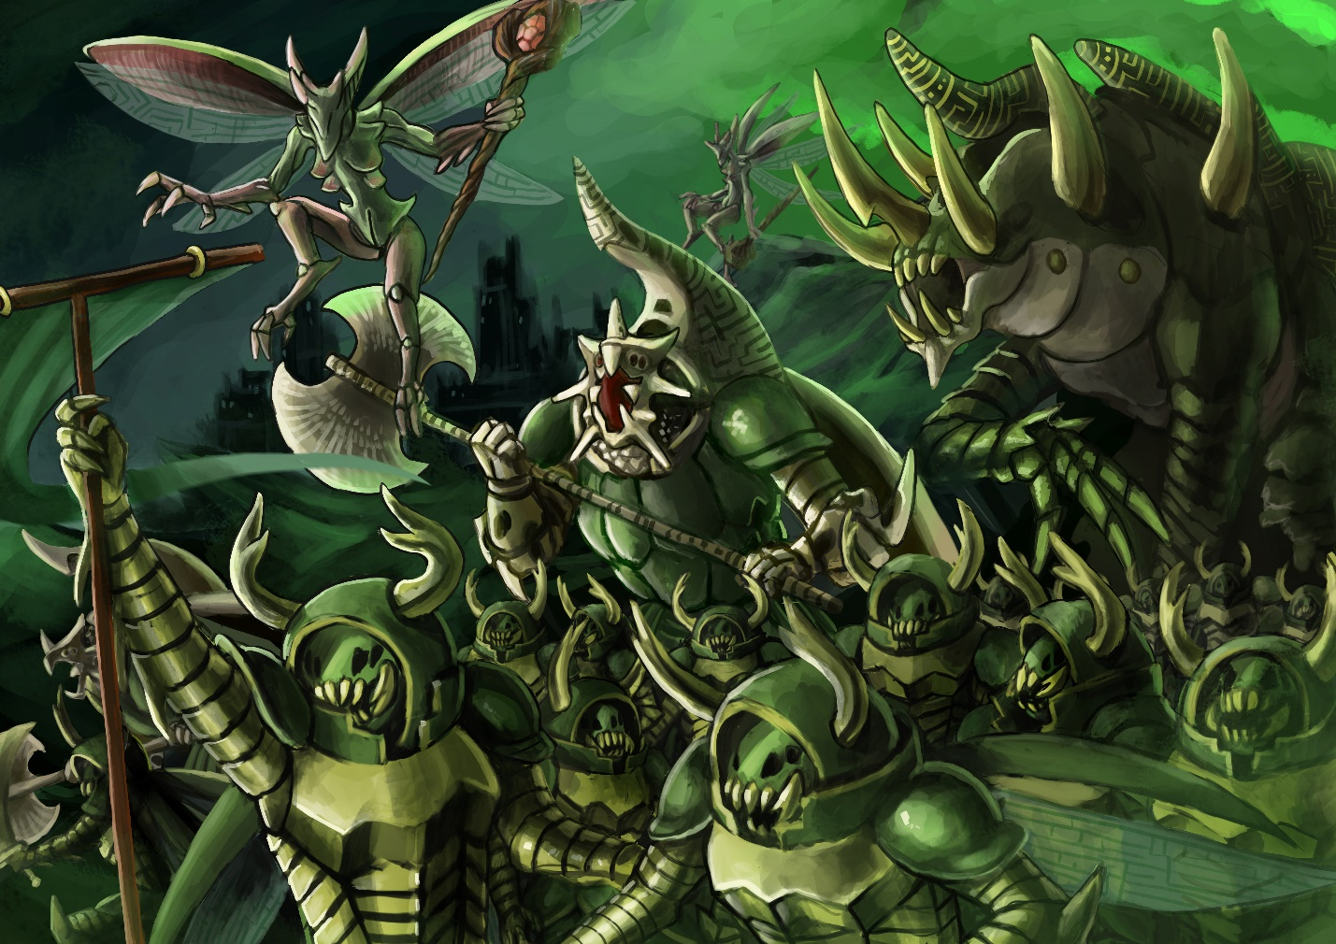

Charters

Order of the Heracleon

Stag Knight

|  |  |  |  |  |  |  |  |
| --- | --- | --- | --- | --- | --- | --- | --- |
| MC | AC | T | P | W | A | F | Cost |
| 1 | 2 | 5 | 5 | 20 | 1 | 0 | 25 |

**Abilities:**

*Relentless 1*: This unit may ignore one Attack Penalty Level

*Dauntless 1:* This unit may ignore one Movement Penalty Level

The Stag Knight is the core of the Hive Court military forces. Each Knight stands between 3 and 4 meters tall and is covered in a thick metallic carapace. Bred for war, the Stag Knight’s exoskeletons are coated in a light flexible steel. Experienced Knights can be gifted with honorary sigil runes by Emissaries of the Queen.

Stag Knights usually remain within the hive, though it isn’t uncommon for squads of them to be given tasks abroad. Stag Knights are high paragons of virtue, and almost all of them are sworn to a charter and an oath. Each charter represents a concept (courage, pragmatism, honor, victory, etc) and its members strive to always represent that virtue. Not all charters are equally represented in all Hives, but virtually all hives adhere to a similar charter system. At some point in their careers, a Knight can choose an oath to which they become bound. When a Knight feels that he is ready, he must undertake a quest which aligns with his desired oath. The quest is chosen by his Emissary and the leader of the charter. The Emissary inscribes a binding rune into his armor, forbidding him from returning until his mission is complete. Upon completion, the Stag Knight swears an oath and receives the rune of his charter and is henceforth imbued with the power of his beliefs. Oathsworn Stag Knights are capable of flight, despite their extreme size. This isn’t without downsides, as the Oathsworn is compelled to always follow his oath regardless of the circumstances.

Hercules Knight

|  |  |  |  |  |  |  |  |
| --- | --- | --- | --- | --- | --- | --- | --- |
| MC | AC | T | P | W | A | F | Cost |
| 0.8 | 2 | 7 | 7 | 40 | 2 | 0 | 50 |

**Abilities:**

*Relentless 2*: This unit may ignore two Attack Penalty Levels

*Dauntless 2:* This unit may ignore two Movement Penalty Levels

*Flying*

The Hercules Knight is a highly versatile combat unit used for situations where a Stag Knight will not suffice. Hercules Knights are relatively rare and are usually found guarding the innermost chambers of a Hive. Their massive frames and steeled carapaces render them almost indestructible to all but the most powerful foes.

A Hercules Knight is created when a Stag Knight performs acts so valorous and noteworthy that they are elevated to the High Order of the Heracleon. They may only be nominated by a Royal Emissary or the Queen herself. Such an honor is immense, for the knights of the Order are the only males permitted in the presence of the Queen. Should they be nominated, they are formed into a cocoon and begin a period of meditation and personal reflection. No two knights have the same visions, and few dare to speak of them. Not all knights are able to complete this task and are left to meditate in silence and isolation until their metamorphosis is complete. Those that do awaken are granted a new name, and their prior deeds are immortalized in the scrolls of their charter.

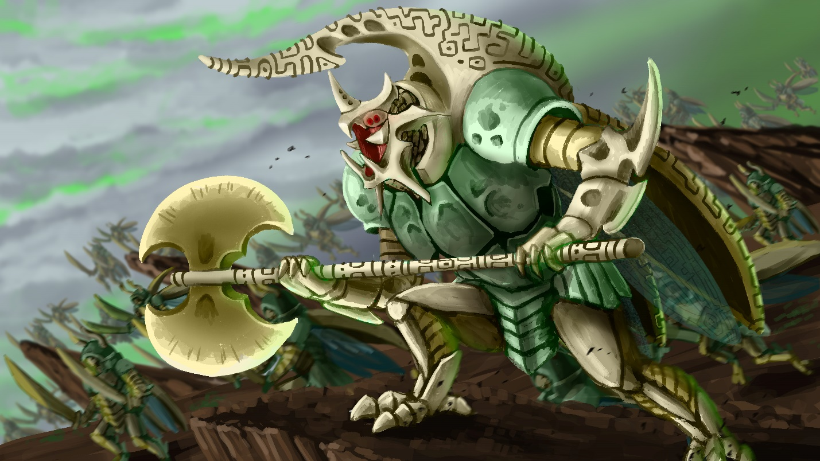

Goliath

|  |  |  |  |  |  |  |  |
| --- | --- | --- | --- | --- | --- | --- | --- |
| MC | AC | T | P | W | A | F | Cost |
| 0.7 | 1.5 | 10 | 10 | 56 | 3 | 0 | 70 |

**Abilities:**

*Relentless 2*: This unit may ignore two Attack Penalty Levels

*Dauntless 2:* This unit may ignore two Movement Penalty Levels

*Flying*

*Mindless:* This unit cannot take a turn or action of its own accord, and has 0 Activation Points

*Conduit: This unit* receives twice the amount of Activation Points spent when under the effects of Royal Decree, but must be within 12” of the casting unit.

The Goliath Beetle is a monstrously large creature used in only the direst of battles. They tower easily ten meters tall over the battlefield. Primarily they are used by the Hives to break entrenched positions or to destroy the deadliest of the enemy’s war machines. The Goliath is so incredibly dangerous that the Queens do not imbue them with any sentience or will of their own. If not under direct control of the Queen or her Emissaries, the Goliath remains immobile; incapable of actions as simple as eating or drinking. Subsequently, each Goliath usually has an Emissary who is responsible for it. Because of the lack of consciousness and bond with the Emissary, Goliaths can enact the Queen’s will with a much higher degree of control and efficiency than any other part of the Hive’s military. A Goliath is created as a result of a failed Ascension Ritual. Those who become lost in their visions become empty husks, their minds filled with vanities and imagined trials. Their mighty forms continue to grow until they burst forth from the cocoon. As a penance, the Emissary who selected the Goliath becomes the Goliath’s keeper, protecting him and guiding his endless destructive force.

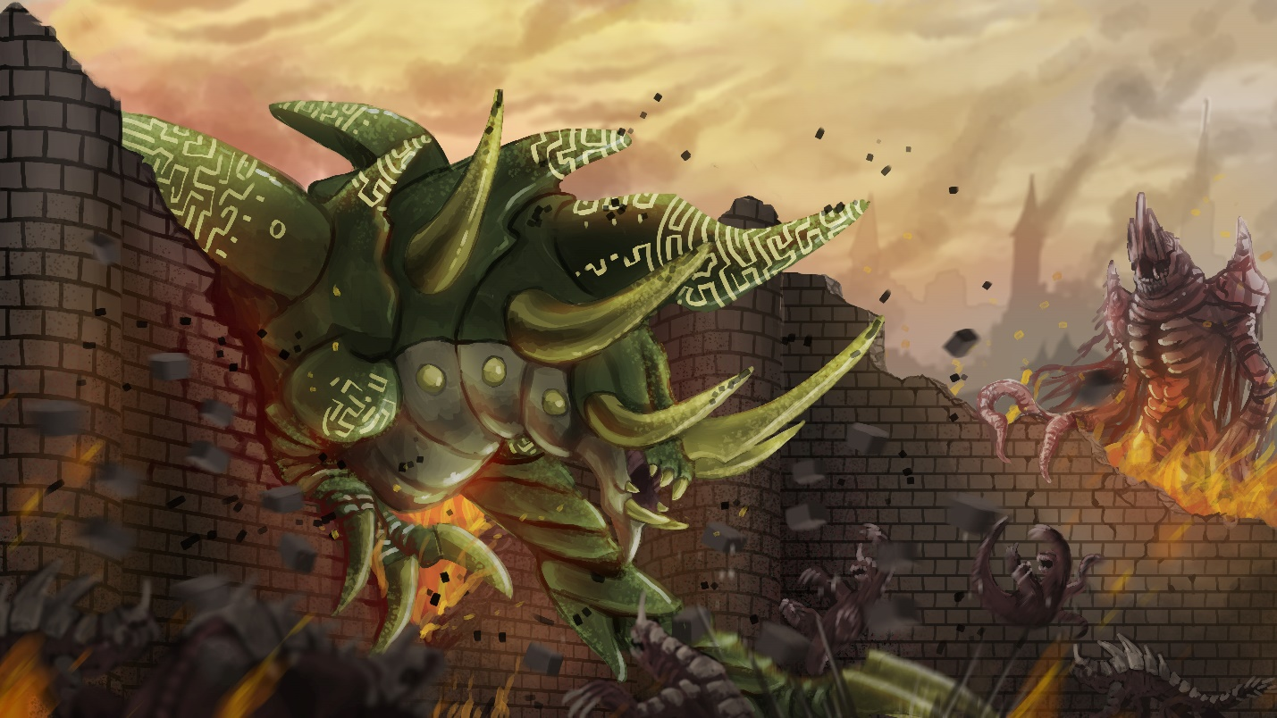

Hive Guard

|  |  |  |  |  |  |  |  |
| --- | --- | --- | --- | --- | --- | --- | --- |
| MC | AC | T | P | W | A | F | Cost |
| 1 | 3 | 4 | 4 | 12 | 0 | 0 | 15 |

**Abilities:**

*Flying*

Lorem ipsum dolor sit amet, consectetur adipiscing elit. Aliquam varius ligula vel tempor eleifend. Mauris nunc nulla, aliquam ac euismod at, bibendum sed sapien. Aenean nec condimentum odio. Pellentesque mauris nunc, mollis eu consectetur vitae, lobortis et ex. Aliquam pharetra, odio sit amet viverra pulvinar, velit velit rhoncus mi, et facilisis erat tortor quis risus. Quisque cursus congue sapien vel bibendum. Class aptent taciti sociosqu ad litora torquent per conubia nostra, per inceptos himenaeos. Quisque porttitor gravida condimentum. Mauris vel sollicitudin arcu. Nam eleifend dignissim libero egestas mollis. Phasellus nisi risus, viverra consequat eros quis, faucibus rhoncus massa. Cras vel leo eros.

Sed vitae ligula dapibus, interdum neque at, malesuada enim. Cras vitae nibh et libero vehicula euismod quis vel magna. Maecenas risus diam, sagittis sit amet ultrices non, hendrerit at nibh. Curabitur viverra elit vel ipsum laoreet, id hendrerit dui fringilla. Aenean finibus neque at nunc porttitor viverra. Ut facilisis ornare ex at interdum. Sed tristique, ante ac suscipit pulvinar, velit tellus placerat ligula, sed imperdiet nisi odio nec diam. Donec enim nisi, fermentum vel libero vulputate, aliquet condimentum odio. Phasellus faucibus interdum mi, nec hendrerit magna consequat quis. Mauris eget metus a nisl varius iaculis. Donec vulputate ligula vel justo tempus hendrerit. In enim augue, rutrum non pellentesque at, egestas ut ipsum. Phasellus auctor mi ut leo malesuada egestas. Vivamus in pellentesque orci, ac pulvinar mi. Curabitur vitae dictum velit.

Vestibulum nec sagittis nibh, in maximus ipsum. Suspendisse potenti. Nam non purus a magna convallis varius. Suspendisse sed felis lacus. Sed nisl massa, placerat vel est vitae, tristique dignissim dolor. Quisque feugiat sagittis lectus, ac porttitor est lobortis sed. Proin pellentesque eu erat non malesuada. Quisque fringilla in elit porta vehicula. Curabitur vel tincidunt urna. Suspendisse porta pharetra libero, sed placerat lectus pellentesque at. In sceleris

# UNIT IMAGE

Royal Emissary

|  |  |  |  |  |  |  |  |
| --- | --- | --- | --- | --- | --- | --- | --- |
| MC | AC | T | P | W | A | F | Cost |
| 1 | 3 | 4 | 3 | 16 | 1 | 2 | 20 |

**Abilities:**

*Flying*

*Spellcaster: Hive Courts*

*Royal Decree:* As an ability, this unit may expend a minimum of one Activation point to grant an immediate turn to a unit within 12”. That unit may use the spent Activation Points to take actions as though it were its turn.

*“*

The Royal Emissary is the embodiment of the Hive Queen’s will. Their primary function is to act on behalf of their Queen as a negotiator, though their ability to command the battlefield is second to none in the Hive Courts. Their light frames and powerful wings enable them to fly through the battle unhindered. However, for more spread-out skirmishes an Emissary might opt to bring a riding wasp.

A Royal Emissary may extend the Queen’s will by directly controlling Knights, granting them a considerable enhancement to their abilities. Though limited by range, this can more than make up for the Hive Court’s lack of numbers. The Emissaries maintain a vigilant watch for particularly exception knights among the units they supervise. It is their ordained role to maintain the ranks of the Heracleon by granting a select few the privilege of the Rite of Ascension. The Knights that fail their ordeal and fall to madness become bonded to the Emissary. It is the Royal Emissary’s sacred duty to keep control of their failed candidate. The exact measurements are unknown to all but the Queens themselves.

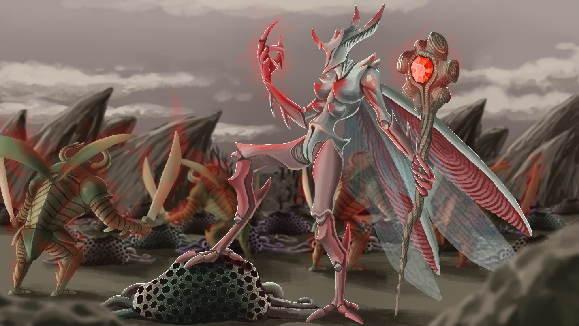

Endless Forest

Lorem ipsum dolor sit amet, consectetur adipiscing elit. Aliquam varius ligula vel tempor eleifend. Mauris nunc nulla, aliquam ac euismod at, bibendum sed sapien. Aenean nec condimentum odio. Pellentesque mauris nunc, mollis eu consectetur vitae, lobortis et ex. Aliquam pharetra, odio sit amet viverra pulvinar, velit velit rhoncus mi, et facilisis erat tortor quis risus. Quisque cursus congue sapien vel bibendum. Class aptent taciti sociosqu ad litora torquent per conubia nostra, per inceptos himenaeos. Quisque porttitor gravida condimentum. Mauris vel sollicitudin arcu. Nam eleifend dignissim libero egestas mollis. Phasellus nisi risus, viverra consequat eros quis, faucibus rhoncus massa. Cras vel leo eros.

Sed vitae ligula dapibus, interdum neque at, malesuada enim. Cras vitae nibh et libero vehicula euismod quis vel magna. Maecenas risus diam, sagittis sit amet ultrices non, hendrerit at nibh. Curabitur viverra elit vel ipsum laoreet, id hendrerit dui fringilla. Aenean finibus neque at nunc porttitor viverra. Ut facilisis ornare ex at interdum. Sed tristique, ante ac suscipit pulvinar, velit tellus placerat ligula, sed imperdiet nisi odio nec diam. Donec enim nisi, fermentum vel libero vulputate, aliquet condimentum odio. Phasellus faucibus interdum mi, nec hendrerit magna consequat quis. Mauris eget metus a nisl varius iaculis. Donec vulputate ligula vel justo tempus hendrerit. In enim augue, rutrum non pellentesque at, egestas ut ipsum. Phasellus auctor mi ut leo malesuada egestas. Vivamus in pellentesque orci, ac pulvinar mi. Curabitur vitae dictum velit.

Vestibulum nec sagittis nibh, in maximus ipsum. Suspendisse potenti. Nam non purus a magna convallis varius. Suspendisse sed felis lacus. Sed nisl massa, placerat vel est vitae, tristique dignissim dolor. Quisque feugiat sagittis lectus, ac porttitor est lobortis sed. Proin pellentesque eu erat non malesuada. Quisque fringilla in elit porta vehicula. Curabitur vel tincidunt urna. Suspendisse porta pharetra libero, sed placerat lectus pellentesque at. In sceleris

Root Cluster

|  |  |  |  |  |  |  |  |
| --- | --- | --- | --- | --- | --- | --- | --- |
| MC | AC | T | P | W | A | F | Cost |
| - | - | 1 | - | 1 | 0 | 2 | 5 |

**Abilities:**

*Root*: The unit is malleable and can be recreated and changed by other units. X represents the current level.

*Seed 12*: The unit is malleable and can be recreated and changed by other units. X represents the current level.

Lorem ipsum dolor sit amet, consectetur adipiscing elit. Aliquam varius ligula vel tempor eleifend. Mauris nunc nulla, aliquam ac euismod at, bibendum sed sapien. Aenean nec condimentum odio. Pellentesque mauris nunc, mollis eu consectetur vitae, lobortis et ex. Aliquam pharetra, odio sit amet viverra pulvinar, velit velit rhoncus mi, et facilisis erat tortor quis risus. Quisque cursus congue sapien vel bibendum. Class aptent taciti sociosqu ad litora torquent per conubia nostra, per inceptos himenaeos. Quisque porttitor gravida condimentum. Mauris vel sollicitudin arcu. Nam eleifend dignissim libero egestas mollis. Phasellus nisi risus, viverra consequat eros quis, faucibus rhoncus massa. Cras vel leo eros.

Sed vitae ligula dapibus, interdum neque at, malesuada enim. Cras vitae nibh et libero vehicula euismod quis vel magna. Maecenas risus diam, sagittis sit amet ultrices non, hendrerit at nibh. Curabitur viverra elit vel ipsum laoreet, id hendrerit dui fringilla. Aenean finibus neque at nunc porttitor viverra. Ut facilisis ornare ex at interdum. Sed tristique, ante ac suscipit pulvinar, velit tellus placerat ligula, sed imperdiet nisi odio nec diam. Donec enim nisi, fermentum vel libero vulputate, aliquet condimentum odio. Phasellus faucibus interdum mi, nec hendrerit magna consequat quis. Mauris eget metus a nisl varius iaculis. Donec vulputate ligula vel justo tempus hendrerit. In enim augue, rutrum non pellentesque at, egestas ut ipsum. Phasellus auctor mi ut leo malesuada egestas. Vivamus in pellentesque orci, ac pulvinar mi. Curabitur vitae dictum velit.

Vestibulum nec sagittis nibh, in maximus ipsum. Suspendisse potenti. Nam non purus a magna convallis varius. Suspendisse sed felis lacus. Sed nisl massa, placerat vel est vitae, tristique dignissim dolor. Quisque feugiat sagittis lectus, ac porttitor est lobortis sed. Proin pellentesque eu erat non malesuada. Quisque fringilla in elit porta vehicula. Curabitur vel tincidunt urna. Suspendisse porta pharetra libero, sed placerat lectus pellentesque at. In sceleris



Lashvine

|  |  |  |  |  |  |  |  |
| --- | --- | --- | --- | --- | --- | --- | --- |
| MC | AC | T | P | W | A | F | Cost |
| 2 | 3 | 2 | 3 | 8 | 0 | 0 | 10 |

**Abilities:**

*Root*: The unit is malleable and can be recreated and changed by other units. X represents the current level.

*Seed 12*: The unit is malleable and can be recreated and changed by other units. X represents the current level.

Lorem ipsum dolor sit amet, consectetur adipiscing elit. Aliquam varius ligula vel tempor eleifend. Mauris nunc nulla, aliquam ac euismod at, bibendum sed sapien. Aenean nec condimentum odio. Pellentesque mauris nunc, mollis eu consectetur vitae, lobortis et ex. Aliquam pharetra, odio sit amet viverra pulvinar, velit velit rhoncus mi, et facilisis erat tortor quis risus. Quisque cursus congue sapien vel bibendum. Class aptent taciti sociosqu ad litora torquent per conubia nostra, per inceptos himenaeos. Quisque porttitor gravida condimentum. Mauris vel sollicitudin arcu. Nam eleifend dignissim libero egestas mollis. Phasellus nisi risus, viverra consequat eros quis, faucibus rhoncus massa. Cras vel leo eros.

Sed vitae ligula dapibus, interdum neque at, malesuada enim. Cras vitae nibh et libero vehicula euismod quis vel magna. Maecenas risus diam, sagittis sit amet ultrices non, hendrerit at nibh. Curabitur viverra elit vel ipsum laoreet, id hendrerit dui fringilla. Aenean finibus neque at nunc porttitor viverra. Ut facilisis ornare ex at interdum. Sed tristique, ante ac suscipit pulvinar, velit tellus placerat ligula, sed imperdiet nisi odio nec diam. Donec enim nisi, fermentum vel libero vulputate, aliquet condimentum odio. Phasellus faucibus interdum mi, nec hendrerit magna consequat quis. Mauris eget metus a nisl varius iaculis. Donec vulputate ligula vel justo tempus hendrerit. In enim augue, rutrum non pellentesque at, egestas ut ipsum. Phasellus auctor mi ut leo malesuada egestas. Vivamus in pellentesque orci, ac pulvinar mi. Curabitur vitae dictum velit.

Vestibulum nec sagittis nibh, in maximus ipsum. Suspendisse potenti. Nam non purus a magna convallis varius. Suspendisse sed felis lacus. Sed nisl massa, placerat vel est vitae, tristique dignissim dolor. Quisque feugiat sagittis lectus, ac porttitor est lobortis sed. Proin pellentesque eu erat non malesuada. Quisque fringilla in elit porta vehicula. Curabitur vel tincidunt urna. Suspendisse porta pharetra libero, sed placerat lectus pellentesque at. In sceleris

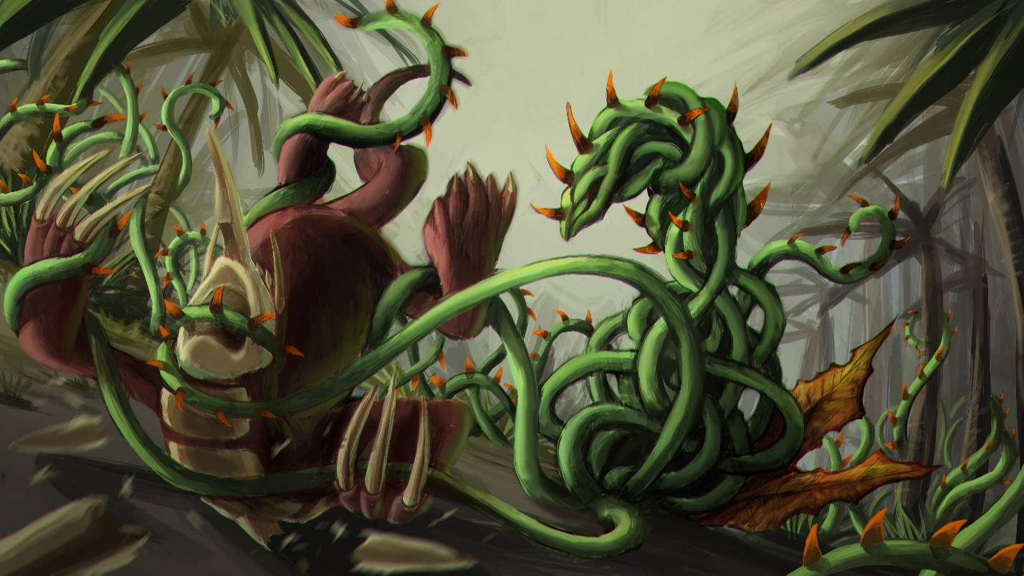

Cloudsower

|  |  |  |  |  |  |  |  |
| --- | --- | --- | --- | --- | --- | --- | --- |
| MC | AC | T | P | W | A | F | Cost |
| 1 | 3 | 2 | 2 | 6 | 0 | 2 | 7 |

**Abilities:**

*Root*: The unit is malleable and can be recreated and changed by other units. X represents the current level.

*Seed 12*: The unit is malleable and can be recreated and changed by other units. X represents the current level.

Lorem ipsum dolor sit amet, consectetur adipiscing elit. Aliquam varius ligula vel tempor eleifend. Mauris nunc nulla, aliquam ac euismod at, bibendum sed sapien. Aenean nec condimentum odio. Pellentesque mauris nunc, mollis eu consectetur vitae, lobortis et ex. Aliquam pharetra, odio sit amet viverra pulvinar, velit velit rhoncus mi, et facilisis erat tortor quis risus. Quisque cursus congue sapien vel bibendum. Class aptent taciti sociosqu ad litora torquent per conubia nostra, per inceptos himenaeos. Quisque porttitor gravida condimentum. Mauris vel sollicitudin arcu. Nam eleifend dignissim libero egestas mollis. Phasellus nisi risus, viverra consequat eros quis, faucibus rhoncus massa. Cras vel leo eros.

Sed vitae ligula dapibus, interdum neque at, malesuada enim. Cras vitae nibh et libero vehicula euismod quis vel magna. Maecenas risus diam, sagittis sit amet ultrices non, hendrerit at nibh. Curabitur viverra elit vel ipsum laoreet, id hendrerit dui fringilla. Aenean finibus neque at nunc porttitor viverra. Ut facilisis ornare ex at interdum. Sed tristique, ante ac suscipit pulvinar, velit tellus placerat ligula, sed imperdiet nisi odio nec diam. Donec enim nisi, fermentum vel libero vulputate, aliquet condimentum odio. Phasellus faucibus interdum mi, nec hendrerit magna consequat quis. Mauris eget metus a nisl varius iaculis. Donec vulputate ligula vel justo tempus hendrerit. In enim augue, rutrum non pellentesque at, egestas ut ipsum. Phasellus auctor mi ut leo malesuada egestas. Vivamus in pellentesque orci, ac pulvinar mi. Curabitur vitae dictum velit.

Vestibulum nec sagittis nibh, in maximus ipsum. Suspendisse potenti. Nam non purus a magna convallis varius. Suspendisse sed felis lacus. Sed nisl massa, placerat vel est vitae, tristique dignissim dolor. Quisque feugiat sagittis lectus, ac porttitor est lobortis sed. Proin pellentesque eu erat non malesuada. Quisque fringilla in elit porta vehicula. Curabitur vel tincidunt urna. Suspendisse porta pharetra libero, sed placerat lectus pellentesque at. In sceleris

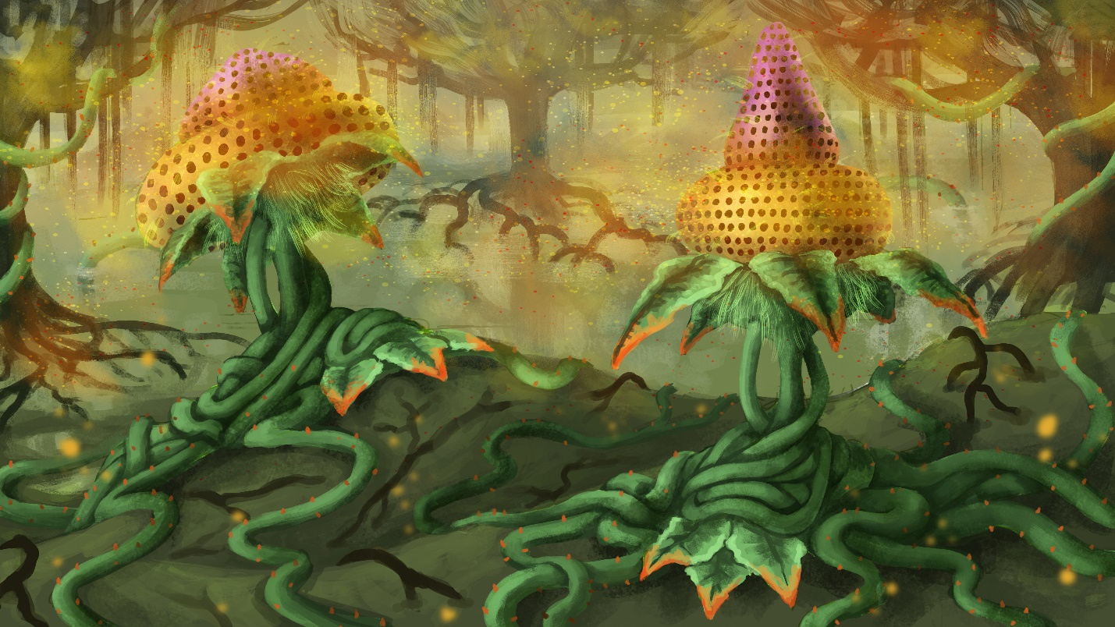

Mine Plant

|  |  |  |  |  |  |  |  |
| --- | --- | --- | --- | --- | --- | --- | --- |
| MC | AC | T | P | W | A | F | Cost |
| 1 | 3 | 2 | 2 | 6 | 0 | 2 | 7 |

**Abilities:**

*Root*: The unit is malleable and can be recreated and changed by other units. X represents the current level.

*Seed 12*: The unit is malleable and can be recreated and changed by other units. X represents the current level.

Lorem ipsum dolor sit amet, consectetur adipiscing elit. Aliquam varius ligula vel tempor eleifend. Mauris nunc nulla, aliquam ac euismod at, bibendum sed sapien. Aenean nec condimentum odio. Pellentesque mauris nunc, mollis eu consectetur vitae, lobortis et ex. Aliquam pharetra, odio sit amet viverra pulvinar, velit velit rhoncus mi, et facilisis erat tortor quis risus. Quisque cursus congue sapien vel bibendum. Class aptent taciti sociosqu ad litora torquent per conubia nostra, per inceptos himenaeos. Quisque porttitor gravida condimentum. Mauris vel sollicitudin arcu. Nam eleifend dignissim libero egestas mollis. Phasellus nisi risus, viverra consequat eros quis, faucibus rhoncus massa. Cras vel leo eros.

Sed vitae ligula dapibus, interdum neque at, malesuada enim. Cras vitae nibh et libero vehicula euismod quis vel magna. Maecenas risus diam, sagittis sit amet ultrices non, hendrerit at nibh. Curabitur viverra elit vel ipsum laoreet, id hendrerit dui fringilla. Aenean finibus neque at nunc porttitor viverra. Ut facilisis ornare ex at interdum. Sed tristique, ante ac suscipit pulvinar, velit tellus placerat ligula, sed imperdiet nisi odio nec diam. Donec enim nisi, fermentum vel libero vulputate, aliquet condimentum odio. Phasellus faucibus interdum mi, nec hendrerit magna consequat quis. Mauris eget metus a nisl varius iaculis. Donec vulputate ligula vel justo tempus hendrerit. In enim augue, rutrum non pellentesque at, egestas ut ipsum. Phasellus auctor mi ut leo malesuada egestas. Vivamus in pellentesque orci, ac pulvinar mi. Curabitur vitae dictum velit.

Vestibulum nec sagittis nibh, in maximus ipsum. Suspendisse potenti. Nam non purus a magna convallis varius. Suspendisse sed felis lacus. Sed nisl massa, placerat vel est vitae, tristique dignissim dolor. Quisque feugiat sagittis lectus, ac porttitor est lobortis sed. Proin pellentesque eu erat non malesuada. Quisque fringilla in elit porta vehicula. Curabitur vel tincidunt urna. Suspendisse porta pharetra libero, sed placerat lectus pellentesque at. In sceleris

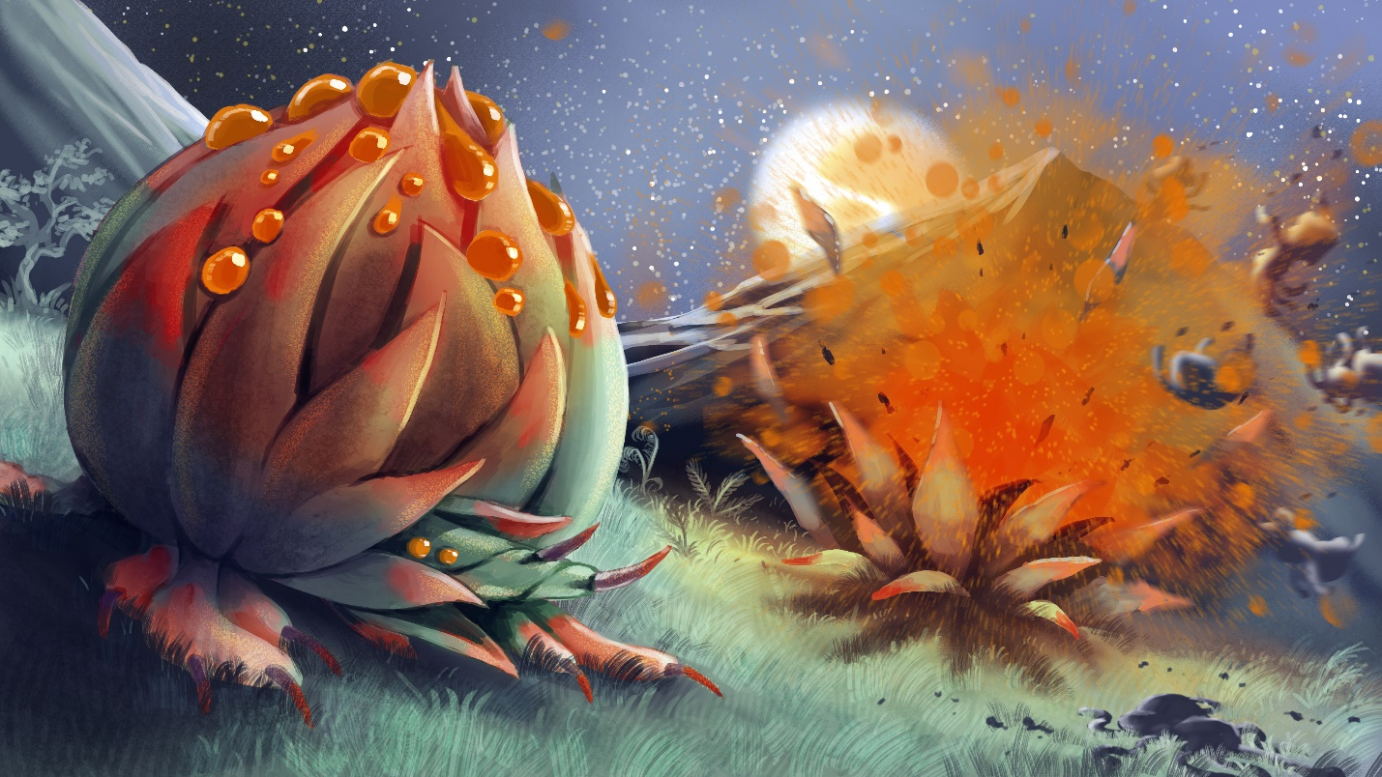

Cannon Plant

|  |  |  |  |  |  |  |  |
| --- | --- | --- | --- | --- | --- | --- | --- |
| MC | AC | T | P | W | A | F | Cost |
| 1 | 3 | 2 | 2 | 6 | 0 | 2 | 7 |

**Abilities:**

*Root*: The unit is malleable and can be recreated and changed by other units. X represents the current level.

*Seed 12*: The unit is malleable and can be recreated and changed by other units. X represents the current level.

Lorem ipsum dolor sit amet, consectetur adipiscing elit. Aliquam varius ligula vel tempor eleifend. Mauris nunc nulla, aliquam ac euismod at, bibendum sed sapien. Aenean nec condimentum odio. Pellentesque mauris nunc, mollis eu consectetur vitae, lobortis et ex. Aliquam pharetra, odio sit amet viverra pulvinar, velit velit rhoncus mi, et facilisis erat tortor quis risus. Quisque cursus congue sapien vel bibendum. Class aptent taciti sociosqu ad litora torquent per conubia nostra, per inceptos himenaeos. Quisque porttitor gravida condimentum. Mauris vel sollicitudin arcu. Nam eleifend dignissim libero egestas mollis. Phasellus nisi risus, viverra consequat eros quis, faucibus rhoncus massa. Cras vel leo eros.

Sed vitae ligula dapibus, interdum neque at, malesuada enim. Cras vitae nibh et libero vehicula euismod quis vel magna. Maecenas risus diam, sagittis sit amet ultrices non, hendrerit at nibh. Curabitur viverra elit vel ipsum laoreet, id hendrerit dui fringilla. Aenean finibus neque at nunc porttitor viverra. Ut facilisis ornare ex at interdum. Sed tristique, ante ac suscipit pulvinar, velit tellus placerat ligula, sed imperdiet nisi odio nec diam. Donec enim nisi, fermentum vel libero vulputate, aliquet condimentum odio. Phasellus faucibus interdum mi, nec hendrerit magna consequat quis. Mauris eget metus a nisl varius iaculis. Donec vulputate ligula vel justo tempus hendrerit. In enim augue, rutrum non pellentesque at, egestas ut ipsum. Phasellus auctor mi ut leo malesuada egestas. Vivamus in pellentesque orci, ac pulvinar mi. Curabitur vitae dictum velit.

Vestibulum nec sagittis nibh, in maximus ipsum. Suspendisse potenti. Nam non purus a magna convallis varius. Suspendisse sed felis lacus. Sed nisl massa, placerat vel est vitae, tristique dignissim dolor. Quisque feugiat sagittis lectus, ac porttitor est lobortis sed. Proin pellentesque eu erat non malesuada. Quisque fringilla in elit porta vehicula. Curabitur vel tincidunt urna. Suspendisse porta pharetra libero, sed placerat lectus pellentesque at. In sceleris

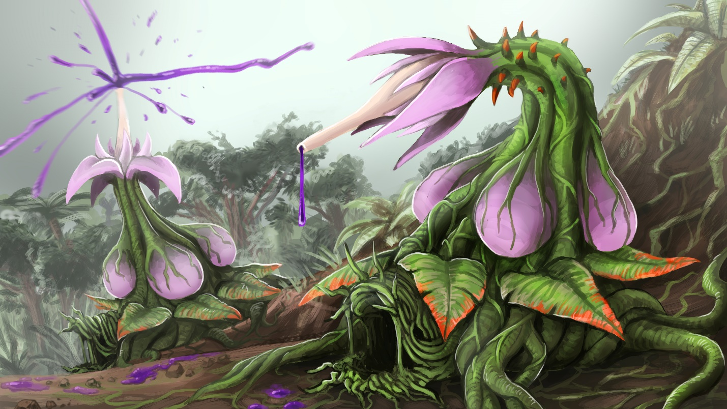

Seedblower

|  |  |  |  |  |  |  |  |
| --- | --- | --- | --- | --- | --- | --- | --- |
| MC | AC | T | P | W | A | F | Cost |
| 1 | 3 | 2 | 2 | 6 | 0 | 2 | 7 |

**Abilities:**

*Root*: The unit is malleable and can be recreated and changed by other units. X represents the current level.

*Seed 12*: The unit is malleable and can be recreated and changed by other units. X represents the current level.

Lorem ipsum dolor sit amet, consectetur adipiscing elit. Aliquam varius ligula vel tempor eleifend. Mauris nunc nulla, aliquam ac euismod at, bibendum sed sapien. Aenean nec condimentum odio. Pellentesque mauris nunc, mollis eu consectetur vitae, lobortis et ex. Aliquam pharetra, odio sit amet viverra pulvinar, velit velit rhoncus mi, et facilisis erat tortor quis risus. Quisque cursus congue sapien vel bibendum. Class aptent taciti sociosqu ad litora torquent per conubia nostra, per inceptos himenaeos. Quisque porttitor gravida condimentum. Mauris vel sollicitudin arcu. Nam eleifend dignissim libero egestas mollis. Phasellus nisi risus, viverra consequat eros quis, faucibus rhoncus massa. Cras vel leo eros.

Sed vitae ligula dapibus, interdum neque at, malesuada enim. Cras vitae nibh et libero vehicula euismod quis vel magna. Maecenas risus diam, sagittis sit amet ultrices non, hendrerit at nibh. Curabitur viverra elit vel ipsum laoreet, id hendrerit dui fringilla. Aenean finibus neque at nunc porttitor viverra. Ut facilisis ornare ex at interdum. Sed tristique, ante ac suscipit pulvinar, velit tellus placerat ligula, sed imperdiet nisi odio nec diam. Donec enim nisi, fermentum vel libero vulputate, aliquet condimentum odio. Phasellus faucibus interdum mi, nec hendrerit magna consequat quis. Mauris eget metus a nisl varius iaculis. Donec vulputate ligula vel justo tempus hendrerit. In enim augue, rutrum non pellentesque at, egestas ut ipsum. Phasellus auctor mi ut leo malesuada egestas. Vivamus in pellentesque orci, ac pulvinar mi. Curabitur vitae dictum velit.

Vestibulum nec sagittis nibh, in maximus ipsum. Suspendisse potenti. Nam non purus a magna convallis varius. Suspendisse sed felis lacus. Sed nisl massa, placerat vel est vitae, tristique dignissim dolor. Quisque feugiat sagittis lectus, ac porttitor est lobortis sed. Proin pellentesque eu erat non malesuada. Quisque fringilla in elit porta vehicula. Curabitur vel tincidunt urna. Suspendisse porta pharetra libero, sed placerat lectus pellentesque at. In sceleris

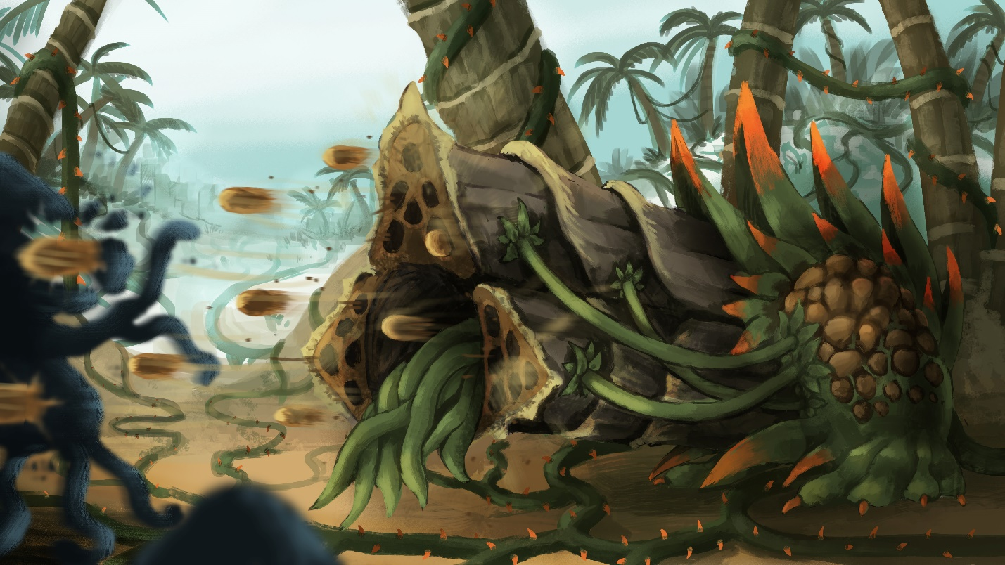

Treant

|  |  |  |  |  |  |  |  |
| --- | --- | --- | --- | --- | --- | --- | --- |
| MC | AC | T | P | W | A | F | Cost |
| 1 | 3 | 2 | 2 | 6 | 0 | 2 | 7 |

**Abilities:**

*Reshape 3*: The unit is malleable and can be recreated and changed by other units. X represents the current level.

Lorem ipsum dolor sit amet, consectetur adipiscing elit. Aliquam varius ligula vel tempor eleifend. Mauris nunc nulla, aliquam ac euismod at, bibendum sed sapien. Aenean nec condimentum odio. Pellentesque mauris nunc, mollis eu consectetur vitae, lobortis et ex. Aliquam pharetra, odio sit amet viverra pulvinar, velit velit rhoncus mi, et facilisis erat tortor quis risus. Quisque cursus congue sapien vel bibendum. Class aptent taciti sociosqu ad litora torquent per conubia nostra, per inceptos himenaeos. Quisque porttitor gravida condimentum. Mauris vel sollicitudin arcu. Nam eleifend dignissim libero egestas mollis. Phasellus nisi risus, viverra consequat eros quis, faucibus rhoncus massa. Cras vel leo eros.

Sed vitae ligula dapibus, interdum neque at, malesuada enim. Cras vitae nibh et libero vehicula euismod quis vel magna. Maecenas risus diam, sagittis sit amet ultrices non, hendrerit at nibh. Curabitur viverra elit vel ipsum laoreet, id hendrerit dui fringilla. Aenean finibus neque at nunc porttitor viverra. Ut facilisis ornare ex at interdum. Sed tristique, ante ac suscipit pulvinar, velit tellus placerat ligula, sed imperdiet nisi odio nec diam. Donec enim nisi, fermentum vel libero vulputate, aliquet condimentum odio. Phasellus faucibus interdum mi, nec hendrerit magna consequat quis. Mauris eget metus a nisl varius iaculis. Donec vulputate ligula vel justo tempus hendrerit. In enim augue, rutrum non pellentesque at, egestas ut ipsum. Phasellus auctor mi ut leo malesuada egestas. Vivamus in pellentesque orci, ac pulvinar mi. Curabitur vitae dictum velit.

Vestibulum nec sagittis nibh, in maximus ipsum. Suspendisse potenti. Nam non purus a magna convallis varius. Suspendisse sed felis lacus. Sed nisl massa, placerat vel est vitae, tristique dignissim dolor. Quisque feugiat sagittis lectus, ac porttitor est lobortis sed. Proin pellentesque eu erat non malesuada. Quisque fringilla in elit porta vehicula. Curabitur vel tincidunt urna. Suspendisse porta pharetra libero, sed placerat lectus pellentesque at. In sceleris

Fleshcrafter Priests

The Fleshcrafter Priests and their fetid fields are all that remains of the shattered glory of the once-great legacy of Man. Millions of years before the present day in-game, mankind reached a societal zenith thanks to his understanding of the arcane arts. Men had learned to access and use the magical energies in “ley lines” flowing unseen through the world. Over thousands of years of use, man slowly evolved to become more linked to this energy - and to one another. People began exhibiting minor telepathic innate abilities, as well as increased rates of mutation and arcane abilities. However, not all humans had the same degree of faith in the increasingly-unstable lines of energy. These Biomancers avoided touching leyline energy directly, instead focusing on healing and augmentative spells. Biomancy involved the use of “Animus”, or the human spirit. The human spirit had become so intertwined with the leylines that mankind’s Animus itself became a source of power. By accessing the latent energies within a person or within themselves, they could perform great feats of restoration and enhancement.

At one point, man went too far in his search for knowledge and power. In an experiment gone awry, the Animus-leyline bridge was overwhelmed and the undercurrents of magic merged with the Animus of man. Instantly, virtually all the souls of the human race were merged into a giant collective, streaming and flowing through the leylines. The human’s bodies were warped and disfigured by the overwhelming amount of energy coursing through them. The lucky ones died instantly, while some were morphed into piles of barely-functional flesh or soul-less husks in the shape of men. Due to their high degree of connection to the elements and leylines, many people fused with the Earth itself. Instead of grass, dirt, and trees there were endless fields of hair, flesh, and bone. Not all was lost though.

The greatest of the Biomancers had managed to protect themselves through limited leyline access and mastery of Animus, though they weren’t completely unaffected. They emerged from their protective warrens and shelters to a nightmare world they could barely fathom, driving many of them to madness. Realizing that they and other scattered conclaves were likely the only remains of the human race, they set to trying to fix things. Though they hadn’t been reconstituted or stripped of their Animus, the Biomancers found that their prior abilities were far stronger. They found that they could easily reshape the living terrain that had once been their people back into men, but the results were hollow. The restored bodies were lacking virtually all Animus, and so were little more than unthinking animals. A man couldn’t be created unless a complete Animus was gathered. Nonetheless, they pushed on, until a curious discovery was made; the Biomancers didn’t age. Initially this seemed to be a boon. What had been a problem constrained to decades now became open-ended. Unable to access the leylines, and with no immediate solution they settled in and began their long work. The decades turned to centuries, and the centuries turned to millennia. At first they tried to remain the remnants of their old civilization. But with such limited numbers and abilities, they inevitably failed. With no masons, the buildings crumbled. With no craftsman, the ability to produce even pig iron began to fade. Eventually the distasteful decision was made to begin utilizing the flesh fields for labor and resources. Countless millennia dragged on, taking a constant toll on the shrinking remnants of the human race. An eternity of memories and almost constant failure drove almost all of them to madness. Their duties became rites and their mission a catechism. No longer mages or academics, they became Priests. And thus we arrive at the present.

The domains of the Fleshcrafter Priests are the stuff of nightmares. Endless fields of writhing flesh. Prairies of hair filled with enormous parasites. Misshapen mouths open and close mindlessly, eager to devour anything that approaches. The Flesh Fields are filled with the steady hum and drone of thousands of mouths crying, groaning, and whimpering. The regions are also patrolled by all sorts of abominations and twisted creatures tailor-made by the Priests to defend their territories. The Priests themselves are almost to a man completely mad. None seem to recall what mankind looked like, or how the state of things came to be. All that persists is the desire to restore humanity. While the individual Priest’s goals and means may vary; the most common means are via growing the fields, acquiring biomass and harvesting Animus to attempt to recreate souls.

Fleshcrafter Priest

|  |  |  |  |  |  |  |  |
| --- | --- | --- | --- | --- | --- | --- | --- |
| MC | AC | T | P | W | A | F | Cost |
| 1 | 3 | 4 | 4 | 20 | 0 | 4 | 20 |

**Abilities:** Spellcaster: Fleshcraft,

*Adaptable*: When selecting this model, you may pay 10 +(X*5) additional points, where X = (current Reshape level -1) to increase this model's Reshape level by one. This ability may be used multiple times, but it must be used one use at a time. (IE: You must upgrade from Reshape 1 to Reshape 2 to Reshape 3. You cannot upgrade directly from Reshape 1 to Reshape 3)

*“The masters of Mankind. Some of us remember a time when such a title would be used with scorn. Those were dark days, and we ascended to glorious divinity from the darkness. Now everything we’ve sought stands before us, threatening everything we’ve thus acquired. We’ve persevered since The Turn, and we won’t be deterred. Let us show them what it means to be a member of the Ministry of Flesh!”*

*-High Chaplain Al-Kazul*

Lorem ipsum dolor sit amet, consectetur adipiscing elit. Aliquam varius ligula vel tempor eleifend. Mauris nunc nulla, aliquam ac euismod at, bibendum sed sapien. Aenean nec condimentum odio. Pellentesque mauris nunc, mollis eu consectetur vitae, lobortis et ex. Aliquam pharetra, odio sit amet viverra pulvinar, velit velit rhoncus mi, et facilisis erat tortor quis risus. Quisque cursus congue sapien vel bibendum. Class aptent taciti sociosqu ad litora torquent per conubia nostra, per inceptos himenaeos. Quisque porttitor gravida condimentum. Mauris vel sollicitudin arcu. Nam eleifend dignissim libero egestas mollis. Phasellus nisi risus, viverra consequat eros quis, faucibus rhoncus massa. Cras vel leo eros.

Sed vitae ligula dapibus, interdum neque at, malesuada enim. Cras vitae nibh et libero vehicula euismod quis vel magna. Maecenas risus diam, sagittis sit amet ultrices non, hendrerit at nibh. Curabitur viverra elit vel ipsum laoreet, id hendrerit dui fringilla. Aenean finibus neque at nunc porttitor viverra. Ut facilisis ornare ex at interdum. Sed tristique, ante ac suscipit pulvinar, velit tellus placerat ligula, sed imperdiet nisi odio nec diam. Donec enim nisi, fermentum vel libero vulputate, aliquet condimentum odio. Phasellus faucibus interdum mi, nec hendrerit magna consequat quis. Mauris eget metus a nisl varius iaculis. Donec vulputate ligula vel justo tempus hendrerit. In enim augue, rutrum non pellentesque at, egestas ut ipsum. Phasellus auctor mi ut leo malesuada egestas. Vivamus in pellentesque orci, ac pulvinar mi. Curabitur vitae dictum velit.

Vestibulum nec sagittis nibh, in maximus ipsum. Suspendisse potenti. Nam non purus a magna convallis varius. Suspendisse sed felis lacus. Sed nisl massa, placerat vel est vitae, tristique dignissim dolor. Quisque feugiat sagittis lectus, ac porttitor est lobortis sed. Proin pellentesque eu erat non malesuada. Quisque fringilla in elit porta vehicula. Curabitur vel tincidunt urna. Suspendisse porta pharetra libero, sed placerat lectus pellentesque at. In sceleris



Flesh Pile

|  |  |  |  |  |  |  |  |
| --- | --- | --- | --- | --- | --- | --- | --- |
| MC | AC | T | P | W | A | F | Cost |
| 3 | - | 1 | 0 | 1 | 0 | 0 | - |

**Abilities:**

*Reshape 0*

Lorem ipsum dolor sit amet, consectetur adipiscing elit. Aliquam varius ligula vel tempor eleifend. Mauris nunc nulla, aliquam ac euismod at, bibendum sed sapien. Aenean nec condimentum odio. Pellentesque mauris nunc, mollis eu consectetur vitae, lobortis et ex. Aliquam pharetra, odio sit amet viverra pulvinar, velit velit rhoncus mi, et facilisis erat tortor quis risus. Quisque cursus congue sapien vel bibendum. Class aptent taciti sociosqu ad litora torquent per conubia nostra, per inceptos himenaeos. Quisque porttitor gravida condimentum. Mauris vel sollicitudin arcu. Nam eleifend dignissim libero egestas mollis. Phasellus nisi risus, viverra consequat eros quis, faucibus rhoncus massa. Cras vel leo eros.

Sed vitae ligula dapibus, interdum neque at, malesuada enim. Cras vitae nibh et libero vehicula euismod quis vel magna. Maecenas risus diam, sagittis sit amet ultrices non, hendrerit at nibh. Curabitur viverra elit vel ipsum laoreet, id hendrerit dui fringilla. Aenean finibus neque at nunc porttitor viverra. Ut facilisis ornare ex at interdum. Sed tristique, ante ac suscipit pulvinar, velit tellus placerat ligula, sed imperdiet nisi odio nec diam. Donec enim nisi, fermentum vel libero vulputate, aliquet condimentum odio. Phasellus faucibus interdum mi, nec hendrerit magna consequat quis. Mauris eget metus a nisl varius iaculis. Donec vulputate ligula vel justo tempus hendrerit. In enim augue, rutrum non pellentesque at, egestas ut ipsum. Phasellus auctor mi ut leo malesuada egestas. Vivamus in pellentesque orci, ac pulvinar mi. Curabitur vitae dictum velit.

Vestibulum nec sagittis nibh, in maximus ipsum. Suspendisse potenti. Nam non purus a magna convallis varius. Suspendisse sed felis lacus. Sed nisl massa, placerat vel est vitae, tristique dignissim dolor. Quisque feugiat sagittis lectus, ac porttitor est lobortis sed. Proin pellentesque eu erat non malesuada. Quisque fringilla in elit porta vehicula. Curabitur vel tincidunt urna. Suspendisse porta pharetra libero, sed placerat lectus pellentesque at. In sceleris



Flesh Drone

|  |  |  |  |  |  |  |  |
| --- | --- | --- | --- | --- | --- | --- | --- |
| MC | AC | T | P | W | A | F | Cost |
| 1 | 3 | 3 | 3 | 8 | 0 | 1 | 10 |

**Abilities:**

*Reshape 1*: The unit is malleable and can be recreated and changed by other units. X represents the current level.

Lorem ipsum dolor sit amet, consectetur adipiscing elit. Aliquam varius ligula vel tempor eleifend. Mauris nunc nulla, aliquam ac euismod at, bibendum sed sapien. Aenean nec condimentum odio. Pellentesque mauris nunc, mollis eu consectetur vitae, lobortis et ex. Aliquam pharetra, odio sit amet viverra pulvinar, velit velit rhoncus mi, et facilisis erat tortor quis risus. Quisque cursus congue sapien vel bibendum. Class aptent taciti sociosqu ad litora torquent per conubia nostra, per inceptos himenaeos. Quisque porttitor gravida condimentum. Mauris vel sollicitudin arcu. Nam eleifend dignissim libero egestas mollis. Phasellus nisi risus, viverra consequat eros quis, faucibus rhoncus massa. Cras vel leo eros.

Sed vitae ligula dapibus, interdum neque at, malesuada enim. Cras vitae nibh et libero vehicula euismod quis vel magna. Maecenas risus diam, sagittis sit amet ultrices non, hendrerit at nibh. Curabitur viverra elit vel ipsum laoreet, id hendrerit dui fringilla. Aenean finibus neque at nunc porttitor viverra. Ut facilisis ornare ex at interdum. Sed tristique, ante ac suscipit pulvinar, velit tellus placerat ligula, sed imperdiet nisi odio nec diam. Donec enim nisi, fermentum vel libero vulputate, aliquet condimentum odio. Phasellus faucibus interdum mi, nec hendrerit magna consequat quis. Mauris eget metus a nisl varius iaculis. Donec vulputate ligula vel justo tempus hendrerit. In enim augue, rutrum non pellentesque at, egestas ut ipsum. Phasellus auctor mi ut leo malesuada egestas. Vivamus in pellentesque orci, ac pulvinar mi. Curabitur vitae dictum velit.

Vestibulum nec sagittis nibh, in maximus ipsum. Suspendisse potenti. Nam non purus a magna convallis varius. Suspendisse sed felis lacus. Sed nisl massa, placerat vel est vitae, tristique dignissim dolor. Quisque feugiat sagittis lectus, ac porttitor est lobortis sed. Proin pellentesque eu erat non malesuada. Quisque fringilla in elit porta vehicula. Curabitur vel tincidunt urna. Suspendisse porta pharetra libero, sed placerat lectus pellentesque at. In sceleris



Flesh Golem

|  |  |  |  |  |  |  |  |
| --- | --- | --- | --- | --- | --- | --- | --- |
| MC | AC | T | P | W | A | F | Cost |
| 0.9 | 2.9 | 4 | 4 | 16 | 0 | 2 | 20 |

**Abilities:**

*Reshape 2*: The unit is malleable and can be recreated and changed by other units. X represents the current level.

Lorem ipsum dolor sit amet, consectetur adipiscing elit. Aliquam varius ligula vel tempor eleifend. Mauris nunc nulla, aliquam ac euismod at, bibendum sed sapien. Aenean nec condimentum odio. Pellentesque mauris nunc, mollis eu consectetur vitae, lobortis et ex. Aliquam pharetra, odio sit amet viverra pulvinar, velit velit rhoncus mi, et facilisis erat tortor quis risus. Quisque cursus congue sapien vel bibendum. Class aptent taciti sociosqu ad litora torquent per conubia nostra, per inceptos himenaeos. Quisque porttitor gravida condimentum. Mauris vel sollicitudin arcu. Nam eleifend dignissim libero egestas mollis. Phasellus nisi risus, viverra consequat eros quis, faucibus rhoncus massa. Cras vel leo eros.

Sed vitae ligula dapibus, interdum neque at, malesuada enim. Cras vitae nibh et libero vehicula euismod quis vel magna. Maecenas risus diam, sagittis sit amet ultrices non, hendrerit at nibh. Curabitur viverra elit vel ipsum laoreet, id hendrerit dui fringilla. Aenean finibus neque at nunc porttitor viverra. Ut facilisis ornare ex at interdum. Sed tristique, ante ac suscipit pulvinar, velit tellus placerat ligula, sed imperdiet nisi odio nec diam. Donec enim nisi, fermentum vel libero vulputate, aliquet condimentum odio. Phasellus faucibus interdum mi, nec hendrerit magna consequat quis. Mauris eget metus a nisl varius iaculis. Donec vulputate ligula vel justo tempus hendrerit. In enim augue, rutrum non pellentesque at, egestas ut ipsum. Phasellus auctor mi ut leo malesuada egestas. Vivamus in pellentesque orci, ac pulvinar mi. Curabitur vitae dictum velit.

Vestibulum nec sagittis nibh, in maximus ipsum. Suspendisse potenti. Nam non purus a magna convallis varius. Suspendisse sed felis lacus. Sed nisl massa, placerat vel est vitae, tristique dignissim dolor. Quisque feugiat sagittis lectus, ac porttitor est lobortis sed. Proin pellentesque eu erat non malesuada. Quisque fringilla in elit porta vehicula. Curabitur vel tincidunt urna. Suspendisse porta pharetra libero, sed placerat lectus pellentesque at. In sceleris



Flesh Behemoth

|  |  |  |  |  |  |  |  |
| --- | --- | --- | --- | --- | --- | --- | --- |
| MC | AC | T | P | W | A | F | Cost |
| 0.9 | 2.8 | 5 | 5 | 28 | 1 | 3 | 35 |

**Abilities:**

*Reshape 3*: The unit is malleable and can be recreated and changed by other units. X represents the current level.

Lorem ipsum dolor sit amet, consectetur adipiscing elit. Aliquam varius ligula vel tempor eleifend. Mauris nunc nulla, aliquam ac euismod at, bibendum sed sapien. Aenean nec condimentum odio. Pellentesque mauris nunc, mollis eu consectetur vitae, lobortis et ex. Aliquam pharetra, odio sit amet viverra pulvinar, velit velit rhoncus mi, et facilisis erat tortor quis risus. Quisque cursus congue sapien vel bibendum. Class aptent taciti sociosqu ad litora torquent per conubia nostra, per inceptos himenaeos. Quisque porttitor gravida condimentum. Mauris vel sollicitudin arcu. Nam eleifend dignissim libero egestas mollis. Phasellus nisi risus, viverra consequat eros quis, faucibus rhoncus massa. Cras vel leo eros.

Sed vitae ligula dapibus, interdum neque at, malesuada enim. Cras vitae nibh et libero vehicula euismod quis vel magna. Maecenas risus diam, sagittis sit amet ultrices non, hendrerit at nibh. Curabitur viverra elit vel ipsum laoreet, id hendrerit dui fringilla. Aenean finibus neque at nunc porttitor viverra. Ut facilisis ornare ex at interdum. Sed tristique, ante ac suscipit pulvinar, velit tellus placerat ligula, sed imperdiet nisi odio nec diam. Donec enim nisi, fermentum vel libero vulputate, aliquet condimentum odio. Phasellus faucibus interdum mi, nec hendrerit magna consequat quis. Mauris eget metus a nisl varius iaculis. Donec vulputate ligula vel justo tempus hendrerit. In enim augue, rutrum non pellentesque at, egestas ut ipsum. Phasellus auctor mi ut leo malesuada egestas. Vivamus in pellentesque orci, ac pulvinar mi. Curabitur vitae dictum velit.

Vestibulum nec sagittis nibh, in maximus ipsum. Suspendisse potenti. Nam non purus a magna convallis varius. Suspendisse sed felis lacus. Sed nisl massa, placerat vel est vitae, tristique dignissim dolor. Quisque feugiat sagittis lectus, ac porttitor est lobortis sed. Proin pellentesque eu erat non malesuada. Quisque fringilla in elit porta vehicula. Curabitur vel tincidunt urna. Suspendisse porta pharetra libero, sed placerat lectus pellentesque at. In sceleris

# FLESH BEHEMOTH IMAGE

Flesh Colossus

|  |  |  |  |  |  |  |  |
| --- | --- | --- | --- | --- | --- | --- | --- |
| MC | AC | T | P | W | A | F | Cost |
| 0.8 | 2.7 | 6 | 6 | 44 | 1 | 4 | 55 |

**Abilities:**

*Reshape 4*: The unit is malleable and can be recreated and changed by other units. X represents the current level.

Lorem ipsum dolor sit amet, consectetur adipiscing elit. Aliquam varius ligula vel tempor eleifend. Mauris nunc nulla, aliquam ac euismod at, bibendum sed sapien. Aenean nec condimentum odio. Pellentesque mauris nunc, mollis eu consectetur vitae, lobortis et ex. Aliquam pharetra, odio sit amet viverra pulvinar, velit velit rhoncus mi, et facilisis erat tortor quis risus. Quisque cursus congue sapien vel bibendum. Class aptent taciti sociosqu ad litora torquent per conubia nostra, per inceptos himenaeos. Quisque porttitor gravida condimentum. Mauris vel sollicitudin arcu. Nam eleifend dignissim libero egestas mollis. Phasellus nisi risus, viverra consequat eros quis, faucibus rhoncus massa. Cras vel leo eros.

Sed vitae ligula dapibus, interdum neque at, malesuada enim. Cras vitae nibh et libero vehicula euismod quis vel magna. Maecenas risus diam, sagittis sit amet ultrices non, hendrerit at nibh. Curabitur viverra elit vel ipsum laoreet, id hendrerit dui fringilla. Aenean finibus neque at nunc porttitor viverra. Ut facilisis ornare ex at interdum. Sed tristique, ante ac suscipit pulvinar, velit tellus placerat ligula, sed imperdiet nisi odio nec diam. Donec enim nisi, fermentum vel libero vulputate, aliquet condimentum odio. Phasellus faucibus interdum mi, nec hendrerit magna consequat quis. Mauris eget metus a nisl varius iaculis. Donec vulputate ligula vel justo tempus hendrerit. In enim augue, rutrum non pellentesque at, egestas ut ipsum. Phasellus auctor mi ut leo malesuada egestas. Vivamus in pellentesque orci, ac pulvinar mi. Curabitur vitae dictum velit.

Vestibulum nec sagittis nibh, in maximus ipsum. Suspendisse potenti. Nam non purus a magna convallis varius. Suspendisse sed felis lacus. Sed nisl massa, placerat vel est vitae, tristique dignissim dolor. Quisque feugiat sagittis lectus, ac porttitor est lobortis sed. Proin pellentesque eu erat non malesuada. Quisque fringilla in elit porta vehicula. Curabitur vel tincidunt urna. Suspendisse porta pharetra libero, sed placerat lectus pellentesque at. In sceleris



Flesh Titan

|  |  |  |  |  |  |  |  |
| --- | --- | --- | --- | --- | --- | --- | --- |
| MC | AC | T | P | W | A | F | Cost |
| 0.8 | 2.6 | 7 | 7 | 64 | 1 | 5 | 80 |

**Abilities:**

*Reshape 5*: The unit is malleable and can be recreated and changed by other units. X represents the current level.

Lorem ipsum dolor sit amet, consectetur adipiscing elit. Aliquam varius ligula vel tempor eleifend. Mauris nunc nulla, aliquam ac euismod at, bibendum sed sapien. Aenean nec condimentum odio. Pellentesque mauris nunc, mollis eu consectetur vitae, lobortis et ex. Aliquam pharetra, odio sit amet viverra pulvinar, velit velit rhoncus mi, et facilisis erat tortor quis risus. Quisque cursus congue sapien vel bibendum. Class aptent taciti sociosqu ad litora torquent per conubia nostra, per inceptos himenaeos. Quisque porttitor gravida condimentum. Mauris vel sollicitudin arcu. Nam eleifend dignissim libero egestas mollis. Phasellus nisi risus, viverra consequat eros quis, faucibus rhoncus massa. Cras vel leo eros.

Sed vitae ligula dapibus, interdum neque at, malesuada enim. Cras vitae nibh et libero vehicula euismod quis vel magna. Maecenas risus diam, sagittis sit amet ultrices non, hendrerit at nibh. Curabitur viverra elit vel ipsum laoreet, id hendrerit dui fringilla. Aenean finibus neque at nunc porttitor viverra. Ut facilisis ornare ex at interdum. Sed tristique, ante ac suscipit pulvinar, velit tellus placerat ligula, sed imperdiet nisi odio nec diam. Donec enim nisi, fermentum vel libero vulputate, aliquet condimentum odio. Phasellus faucibus interdum mi, nec hendrerit magna consequat quis. Mauris eget metus a nisl varius iaculis. Donec vulputate ligula vel justo tempus hendrerit. In enim augue, rutrum non pellentesque at, egestas ut ipsum. Phasellus auctor mi ut leo malesuada egestas. Vivamus in pellentesque orci, ac pulvinar mi. Curabitur vitae dictum velit.

Vestibulum nec sagittis nibh, in maximus ipsum. Suspendisse potenti. Nam non purus a magna convallis varius. Suspendisse sed felis lacus. Sed nisl massa, placerat vel est vitae, tristique dignissim dolor. Quisque feugiat sagittis lectus, ac porttitor est lobortis sed. Proin pellentesque eu erat non malesuada. Quisque fringilla in elit porta vehicula. Curabitur vel tincidunt urna. Suspendisse porta pharetra libero, sed placerat lectus pellentesque at. In sceleris



Shroomin

Lorem ipsum dolor sit amet, consectetur adipiscing elit. Aliquam varius ligula vel tempor eleifend. Mauris nunc nulla, aliquam ac euismod at, bibendum sed sapien. Aenean nec condimentum odio. Pellentesque mauris nunc, mollis eu consectetur vitae, lobortis et ex. Aliquam pharetra, odio sit amet viverra pulvinar, velit velit rhoncus mi, et facilisis erat tortor quis risus. Quisque cursus congue sapien vel bibendum. Class aptent taciti sociosqu ad litora torquent per conubia nostra, per inceptos himenaeos. Quisque porttitor gravida condimentum. Mauris vel sollicitudin arcu. Nam eleifend dignissim libero egestas mollis. Phasellus nisi risus, viverra consequat eros quis, faucibus rhoncus massa. Cras vel leo eros.

Sed vitae ligula dapibus, interdum neque at, malesuada enim. Cras vitae nibh et libero vehicula euismod quis vel magna. Maecenas risus diam, sagittis sit amet ultrices non, hendrerit at nibh. Curabitur viverra elit vel ipsum laoreet, id hendrerit dui fringilla. Aenean finibus neque at nunc porttitor viverra. Ut facilisis ornare ex at interdum. Sed tristique, ante ac suscipit pulvinar, velit tellus placerat ligula, sed imperdiet nisi odio nec diam. Donec enim nisi, fermentum vel libero vulputate, aliquet condimentum odio. Phasellus faucibus interdum mi, nec hendrerit magna consequat quis. Mauris eget metus a nisl varius iaculis. Donec vulputate ligula vel justo tempus hendrerit. In enim augue, rutrum non pellentesque at, egestas ut ipsum. Phasellus auctor mi ut leo malesuada egestas. Vivamus in pellentesque orci, ac pulvinar mi. Curabitur vitae dictum velit.

Vestibulum nec sagittis nibh, in maximus ipsum. Suspendisse potenti. Nam non purus a magna convallis varius. Suspendisse sed felis lacus. Sed nisl massa, placerat vel est vitae, tristique dignissim dolor. Quisque feugiat sagittis lectus, ac porttitor est lobortis sed. Proin pellentesque eu erat non malesuada. Quisque fringilla in elit porta vehicula. Curabitur vel tincidunt urna. Suspendisse porta pharetra libero, sed placerat lectus pellentesque at. In sceleris



Grunt

|  |  |  |  |  |  |  |  |
| --- | --- | --- | --- | --- | --- | --- | --- |
| MC | AC | T | P | W | A | F | Cost |
| 1 | 3 | 2 | 2 | 6 | 0 | 2 | 7 |

**Abilities:**

*Reshape 3*: The unit is malleable and can be recreated and changed by other units. X represents the current level.

Lorem ipsum dolor sit amet, consectetur adipiscing elit. Aliquam varius ligula vel tempor eleifend. Mauris nunc nulla, aliquam ac euismod at, bibendum sed sapien. Aenean nec condimentum odio. Pellentesque mauris nunc, mollis eu consectetur vitae, lobortis et ex. Aliquam pharetra, odio sit amet viverra pulvinar, velit velit rhoncus mi, et facilisis erat tortor quis risus. Quisque cursus congue sapien vel bibendum. Class aptent taciti sociosqu ad litora torquent per conubia nostra, per inceptos himenaeos. Quisque porttitor gravida condimentum. Mauris vel sollicitudin arcu. Nam eleifend dignissim libero egestas mollis. Phasellus nisi risus, viverra consequat eros quis, faucibus rhoncus massa. Cras vel leo eros.

Sed vitae ligula dapibus, interdum neque at, malesuada enim. Cras vitae nibh et libero vehicula euismod quis vel magna. Maecenas risus diam, sagittis sit amet ultrices non, hendrerit at nibh. Curabitur viverra elit vel ipsum laoreet, id hendrerit dui fringilla. Aenean finibus neque at nunc porttitor viverra. Ut facilisis ornare ex at interdum. Sed tristique, ante ac suscipit pulvinar, velit tellus placerat ligula, sed imperdiet nisi odio nec diam. Donec enim nisi, fermentum vel libero vulputate, aliquet condimentum odio. Phasellus faucibus interdum mi, nec hendrerit magna consequat quis. Mauris eget metus a nisl varius iaculis. Donec vulputate ligula vel justo tempus hendrerit. In enim augue, rutrum non pellentesque at, egestas ut ipsum. Phasellus auctor mi ut leo malesuada egestas. Vivamus in pellentesque orci, ac pulvinar mi. Curabitur vitae dictum velit.

Vestibulum nec sagittis nibh, in maximus ipsum. Suspendisse potenti. Nam non purus a magna convallis varius. Suspendisse sed felis lacus. Sed nisl massa, placerat vel est vitae, tristique dignissim dolor. Quisque feugiat sagittis lectus, ac porttitor est lobortis sed. Proin pellentesque eu erat non malesuada. Quisque fringilla in elit porta vehicula. Curabitur vel tincidunt urna. Suspendisse porta pharetra libero, sed placerat lectus pellentesque at. In sceleris



Sporeburster

|  |  |  |  |  |  |  |  |
| --- | --- | --- | --- | --- | --- | --- | --- |
| MC | AC | T | P | W | A | F | Cost |
| 1 | 3 | 2 | 2 | 7 | 0 | 2 | 9 |

**Abilities:**

*Reshape 3*: The unit is malleable and can be recreated and changed by other units. X represents the current level.

Lorem ipsum dolor sit amet, consectetur adipiscing elit. Aliquam varius ligula vel tempor eleifend. Mauris nunc nulla, aliquam ac euismod at, bibendum sed sapien. Aenean nec condimentum odio. Pellentesque mauris nunc, mollis eu consectetur vitae, lobortis et ex. Aliquam pharetra, odio sit amet viverra pulvinar, velit velit rhoncus mi, et facilisis erat tortor quis risus. Quisque cursus congue sapien vel bibendum. Class aptent taciti sociosqu ad litora torquent per conubia nostra, per inceptos himenaeos. Quisque porttitor gravida condimentum. Mauris vel sollicitudin arcu. Nam eleifend dignissim libero egestas mollis. Phasellus nisi risus, viverra consequat eros quis, faucibus rhoncus massa. Cras vel leo eros.

Sed vitae ligula dapibus, interdum neque at, malesuada enim. Cras vitae nibh et libero vehicula euismod quis vel magna. Maecenas risus diam, sagittis sit amet ultrices non, hendrerit at nibh. Curabitur viverra elit vel ipsum laoreet, id hendrerit dui fringilla. Aenean finibus neque at nunc porttitor viverra. Ut facilisis ornare ex at interdum. Sed tristique, ante ac suscipit pulvinar, velit tellus placerat ligula, sed imperdiet nisi odio nec diam. Donec enim nisi, fermentum vel libero vulputate, aliquet condimentum odio. Phasellus faucibus interdum mi, nec hendrerit magna consequat quis. Mauris eget metus a nisl varius iaculis. Donec vulputate ligula vel justo tempus hendrerit. In enim augue, rutrum non pellentesque at, egestas ut ipsum. Phasellus auctor mi ut leo malesuada egestas. Vivamus in pellentesque orci, ac pulvinar mi. Curabitur vitae dictum velit.

Vestibulum nec sagittis nibh, in maximus ipsum. Suspendisse potenti. Nam non purus a magna convallis varius. Suspendisse sed felis lacus. Sed nisl massa, placerat vel est vitae, tristique dignissim dolor. Quisque feugiat sagittis lectus, ac porttitor est lobortis sed. Proin pellentesque eu erat non malesuada. Quisque fringilla in elit porta vehicula. Curabitur vel tincidunt urna. Suspendisse porta pharetra libero, sed placerat lectus pellentesque at. In sceleris



Shaman

|  |  |  |  |  |  |  |  |
| --- | --- | --- | --- | --- | --- | --- | --- |
| MC | AC | T | P | W | A | F | Cost |
| 1.5 | 3 | 2 | 2 | 10 | 0 | 2 | 10 |

**Abilities:**

*Reshape 3*: The unit is malleable and can be recreated and changed by other units. X represents the current level.

Lorem ipsum dolor sit amet, consectetur adipiscing elit. Aliquam varius ligula vel tempor eleifend. Mauris nunc nulla, aliquam ac euismod at, bibendum sed sapien. Aenean nec condimentum odio. Pellentesque mauris nunc, mollis eu consectetur vitae, lobortis et ex. Aliquam pharetra, odio sit amet viverra pulvinar, velit velit rhoncus mi, et facilisis erat tortor quis risus. Quisque cursus congue sapien vel bibendum. Class aptent taciti sociosqu ad litora torquent per conubia nostra, per inceptos himenaeos. Quisque porttitor gravida condimentum. Mauris vel sollicitudin arcu. Nam eleifend dignissim libero egestas mollis. Phasellus nisi risus, viverra consequat eros quis, faucibus rhoncus massa. Cras vel leo eros.

Sed vitae ligula dapibus, interdum neque at, malesuada enim. Cras vitae nibh et libero vehicula euismod quis vel magna. Maecenas risus diam, sagittis sit amet ultrices non, hendrerit at nibh. Curabitur viverra elit vel ipsum laoreet, id hendrerit dui fringilla. Aenean finibus neque at nunc porttitor viverra. Ut facilisis ornare ex at interdum. Sed tristique, ante ac suscipit pulvinar, velit tellus placerat ligula, sed imperdiet nisi odio nec diam. Donec enim nisi, fermentum vel libero vulputate, aliquet condimentum odio. Phasellus faucibus interdum mi, nec hendrerit magna consequat quis. Mauris eget metus a nisl varius iaculis. Donec vulputate ligula vel justo tempus hendrerit. In enim augue, rutrum non pellentesque at, egestas ut ipsum. Phasellus auctor mi ut leo malesuada egestas. Vivamus in pellentesque orci, ac pulvinar mi. Curabitur vitae dictum velit.

Vestibulum nec sagittis nibh, in maximus ipsum. Suspendisse potenti. Nam non purus a magna convallis varius. Suspendisse sed felis lacus. Sed nisl massa, placerat vel est vitae, tristique dignissim dolor. Quisque feugiat sagittis lectus, ac porttitor est lobortis sed. Proin pellentesque eu erat non malesuada. Quisque fringilla in elit porta vehicula. Curabitur vel tincidunt urna. Suspendisse porta pharetra libero, sed placerat lectus pellentesque at. In sceleris

# UNIT IMAGE